

Building space rental Database Management System

CIS 9340 Final project

Submitted by: Noyonika Roy Ridwik Modi Jayant Bishnoi Yooeun Park Ayush Vyas

TABLE OF CONTENTS

**Business Scenario** **2**

**ER Model using UML Notation** **3**

**Conversion to Relational Model** **6**

**Normalization** **6**

**Creating the Database Schema with SQL** **13**

**Database Application** **14**

**Conclusions** **20**

# Business Scenario

One Centre Property Solutions owns and provides rented spaces for commercial uses such as Restaurants, offices (private, public), BPO’s, shops, cafes, movie theatre, gym, banks, and ATMs etc.

Till now we have been using paper logbooks, spreadsheets, notes and other ways to keep track of all records that are required in this business. Now, we are building a database system for our business to have an organized set of data and to remove manual tracking systems. This will help in removing manual error, improving accuracy and will also help us in organizing a big set of data.

In our business, customers can rent one of our properties according to their needs. Customers can visit our leasing office or book an appointment online through which they get assigned a broker who will help them look for a property with the specifications as per their requirements. We need to keep track of customer records and their information along with their requirements. Once the customer selects the desired property. Our dedicated teams in each department will help in completing all the formalities regarding this matter. A contract is drawn up where tenant information is updated along with other renting details. We also keep track of all the employees and data coming across the finance team, marketing team, IT team, building maintenance team, leasing office team and legal team.

Once the customer rents a property, we need to track the finances (rent and loans) which is handled by our Finance Team. Each property is up to code and is maintained by our dedicated Maintenance Team. Our in-house Legal team manages contracts and services, and we also have a Marketing team that advertises our properties to potential new customers.

Challenges during setting up the company concept:

The purpose of our company is to render a rental service. The main challenge here was to imitate the working of a real company. After a fair amount of research on rental companies and through brainstorming we came up with a plan that emulates the working of an actual company and what data would be required to be kept track of in such an institution. We even went a little further to include the marketing team as we figured that would also be integral to a business.

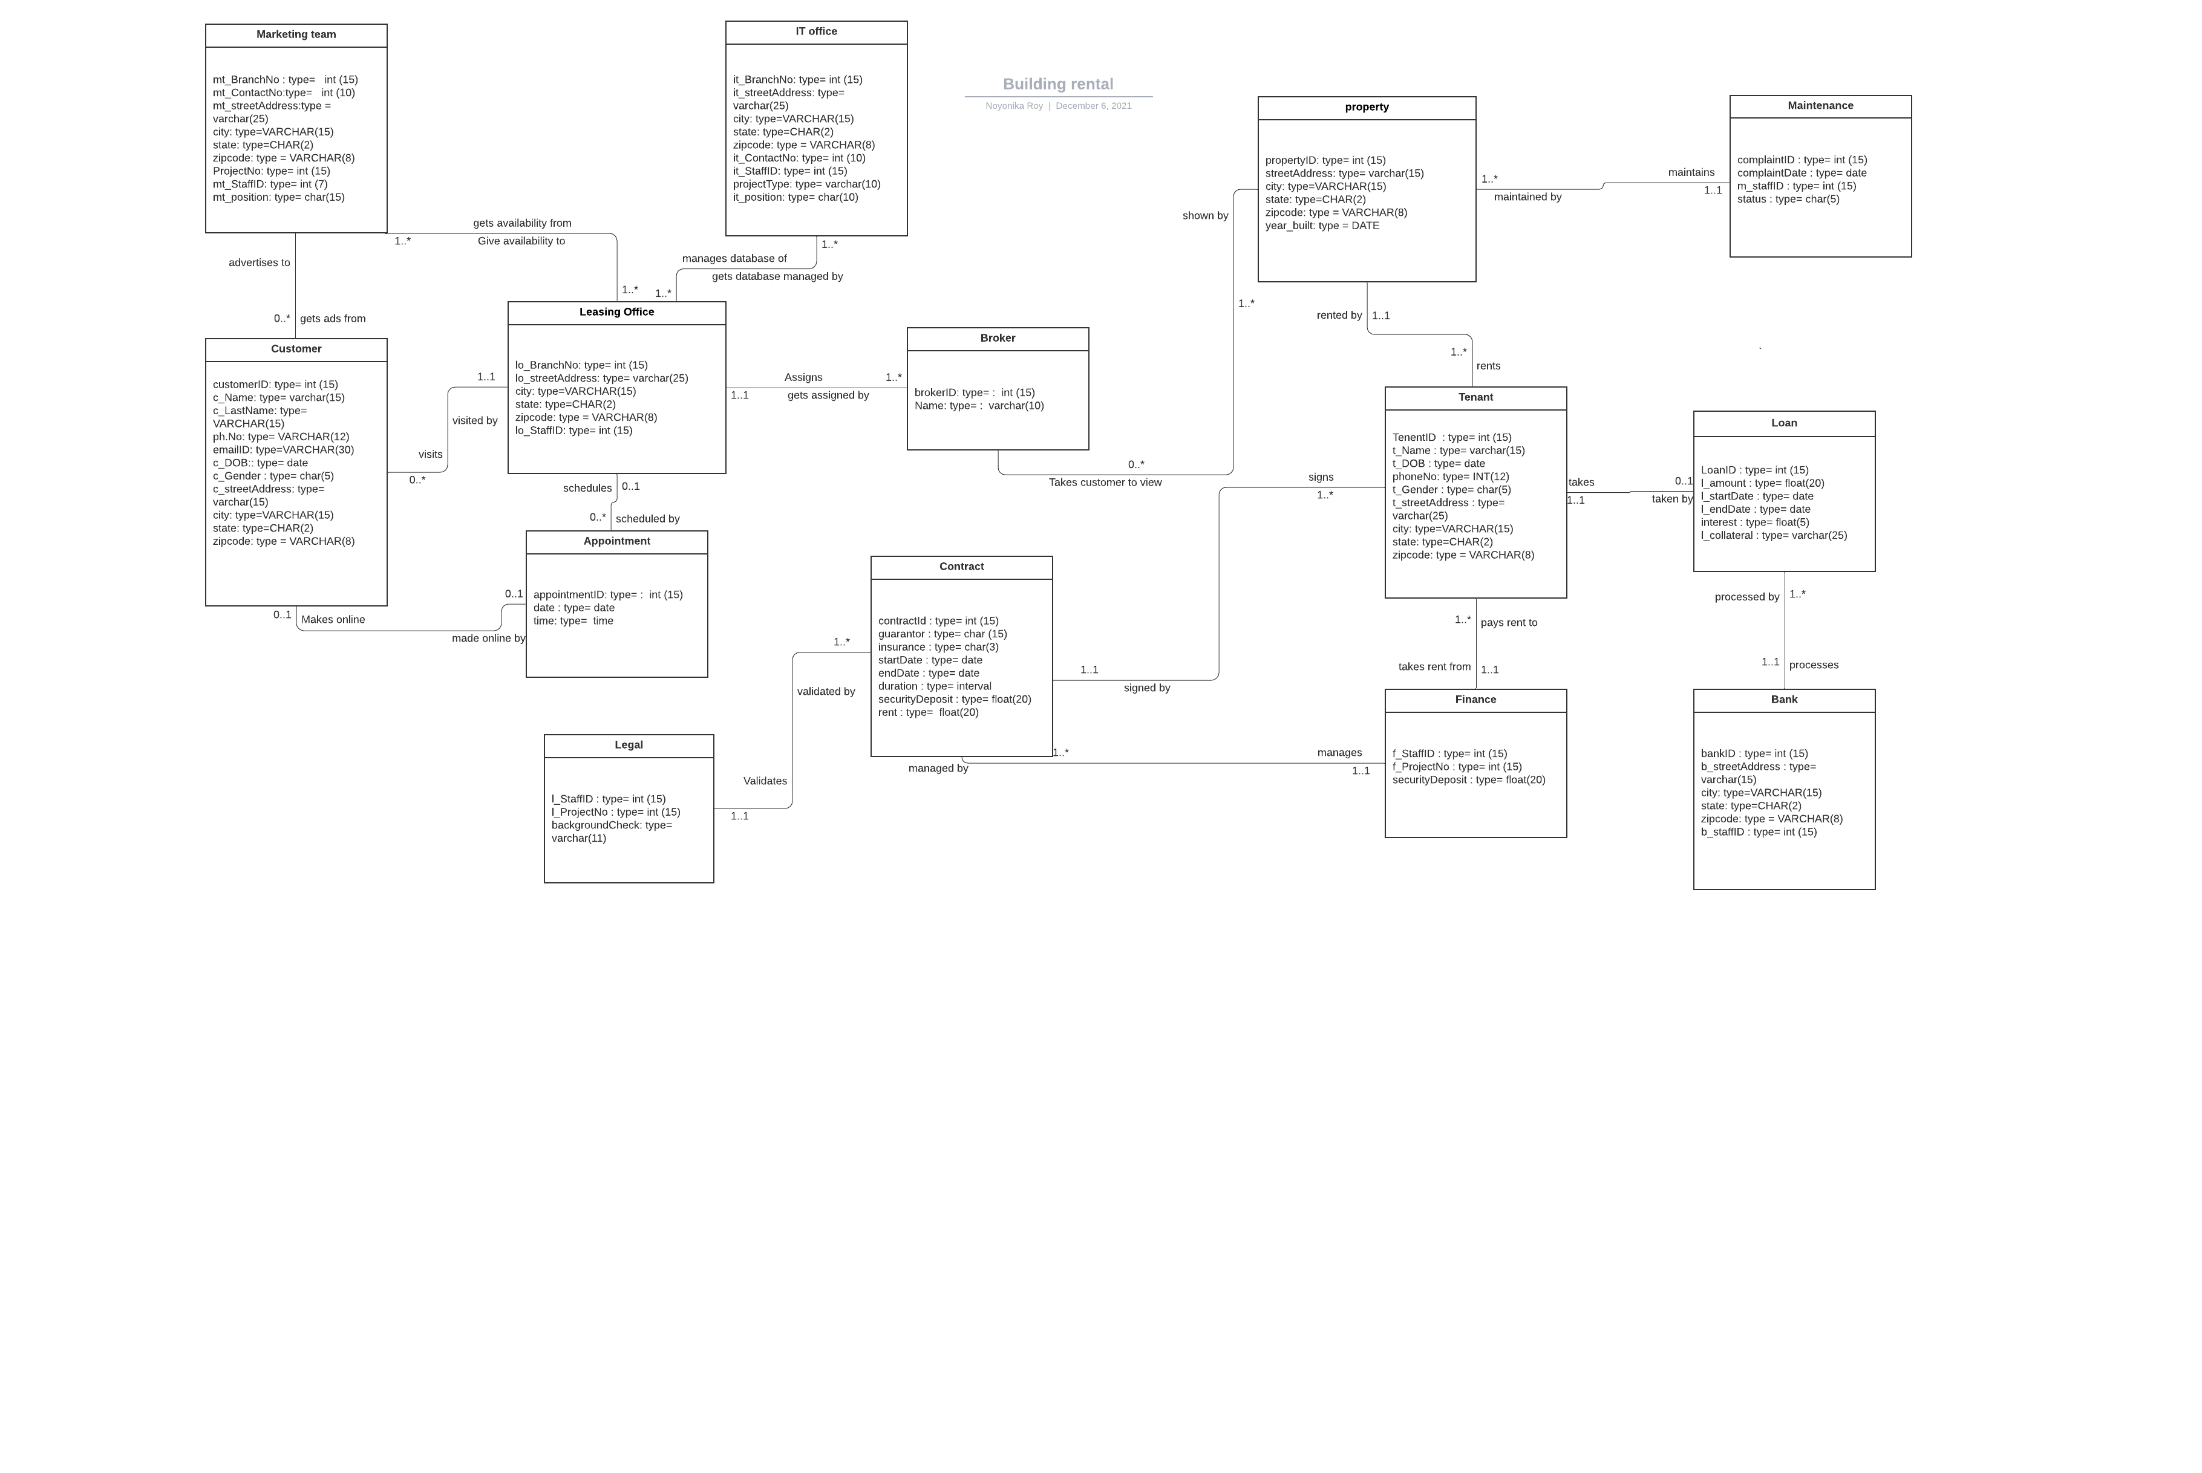

# ER Model using UML Notation

Relationship sentences:

1. Marketing team must get availability from one or many Leasing offices
2. Leasing office must give availability to one or many marketing teams
3. Marketing team may advertise to none to many customers
4. Customer may get ads from none to many Marketing teams
5. Customer may visit one and only one Leasing office
6. Leasing office may be visited by none to many customers
7. IT office must manage database of one or more leasing offices
8. Leasing office must get their database managed by one or more IT offices
9. Customer may make zero or 1 appointment online
10. Appointment may be made online by zero or 1 customer
11. Leasing office may schedule zero to many appointments
12. Appointment may be scheduled by zero to 1 leasing office
13. Leasing office must assign one to many brokers
14. Broker must be assigned by one and only 1 leasing office
15. Broker must take customer to view one or more properties
16. Property may be shown by zero to many brokers
17. Property must be maintained by 1 and only 1 maintenance team
18. Maintenance team must maintain one or more properties
19. Property must be rented by one or more tenants
20. Tenant must rent one and only one property
21. Tenant must sign one and only one contract
22. Contract must be signed by one or more tenants
23. Legal must validate one or more contracts
24. Contract must be validated by one and only one Legal team
25. Contract must be managed by one and only one finance team
26. Finance team must manage one or more contracts
27. Tenant must pay rent to one and only one finance team
28. Finance team must take rent from one or many tenants
29. Tenant may take zero to one loan
30. Loan may be taken by one and only one tenant
31. Loan must be processed by one and only one bank
32. Bank must process one to many loans

# 

Challenges faced while making the ER diagram:

The ER diagram is a representative tool of conceptual modeling and easily represents the relationship with data existing in the real world. We had the theme of building rental, and there was no difficulty in identifying entities after we wrote out our business scenario. In addition, in the process of showing the relationship between entities we established the multiplicities. However, as the number of entities increased, we needed time in identifying the correlations between them and keeping track of the cardinality.

# 

# 3. Conversion to Relational Model

Marketing Team(mt_BranchNo, PropertyID(fk), mt_ContactNo, mt_streetAddress, city, state, zipcode, ProjectNo, mt_StaffID, mt_position)

Customer(customerID, c_Name, c_DOB, c_Gender, c_streetAddress, city, state, zipcode)

Leasing Office(lo_BranchNo, lo_StaffID ,lo_streetAddress, city, state, zipcode, contractID(fk))

IT Office(it_BranchNo, , it_StaffID, it_streetAddress, city, state, zipcode, it_ContactNo, projectType, it_position)

Broker(brokerID, Name, PropertyID(fk))

Appointment(appointmentID, Date, Time, customerID(fk))

Property(propertyID, streetAddress, city, state, zipcode, brokerID(fk),year_built) Maintenance(complaintID, complaintDate, m_staffID, status, propertyID(fk))

Legal(l_staffID, l_ProjectNo, contactID(fk),backgroundCheck)

Contract(contractID, guarantor, insurance, stateDate, endDate, duration, tenantID(fk), propertyID(fk), l_Staffid(fk), f_StaffID(fk), securityDeposit, rent)

Tenant(TenantID, t_Name, t_DOB, t_Gendor, t_Address, propertyID(fk))

Loan(LoanID, contractID(fk), l_amount, l_startDate,l_endDate, interest, l_collateral,)

Finance(f_StaffID,f_ProjectNo, loanID(fk),contractID(fk),securityDeposit)

Bank(bankID, bankID(fk), b_Address, b_staffID, loanID(fk))

Challenges while converting to relational model:

Our team has faced certain challenges while converting the conceptual ER model into the logical relational model. The relation sentences get complex as it involves the situation that exists between two database tables when one table has a foreign key that references the primary key of the other table.Every department in the company had a unique identification with an independent existence to be differentiated with, it comes with a challenge to relate the unique keys to each other.

We needed to keep track of employees in each department, and there were multiple departments in our company. Most of the department has entities and attributes that are dependent on the other departments. Customer, broker, leasing office, and other departments can co-exist in multiple departments, so to arrange all the relations in a meaningful manner is defined in the relationship sentences.Each relation is defined with minimum or maximum cardinality which should make sense.

# Normalization

1. Marketing Team(mt_BranchNo, PropertyID(fk), mt_contactNo, mt_buildingNo, mt_street, mt_city, mt_state, mt_zipcode, mt_StaffID, mt_position)

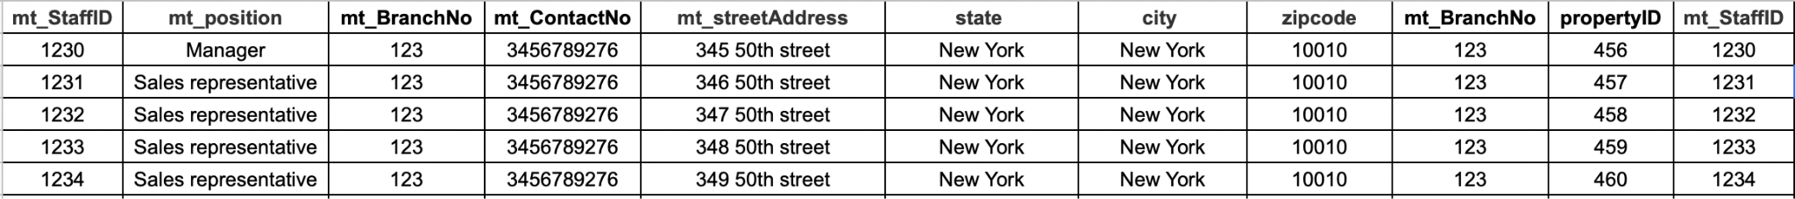

**Key: mt_BranchNo, propertyID**

FD: (Functional Dependency)

*FD1: mt_BranchNo→ mt_contactNo, mt_streetAddress, mt_city, mt_state, mt_zipcode*

*FD2: mt_BranchNo, propertyID→ mt_StaffID*

*FD3: mt_StaffID→ mt_position*

**1NF:** Since the columns have atomic values and have consistent data types we can say it’s in 1NF

**2NF:** Partial dependency FD1

Making new entities: MKT Branch Loc and Marketing Team

Entities in 2NF :

1. Marketing Team(mt_BranchNo, PropertyID(fk), mt_StaffID, mt_position)

*FD4: mt_BranchNo, propertyID→ mt_StaffID*

*FD5: mt_StaffID→ mt_position*

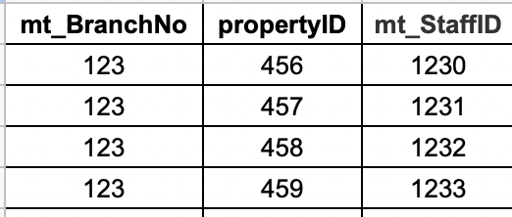

1. MKT Branch Loc(mt_BranchNo, mt_contactNo, mt_streetAdress, mt_city, mt_state, mt_zipcode)

*FD6: mt_BranchNo→ mt_contactNo, mt_streetAddress, mt_city, mt_state, mt_zipcode*

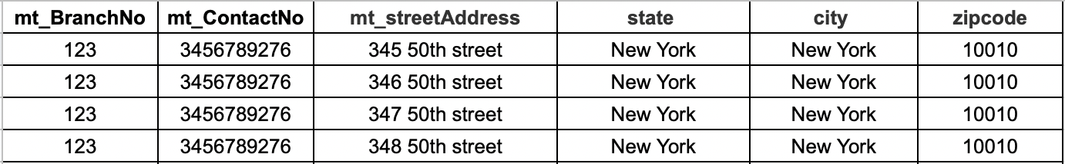

**3NF:** transitive dependency in FD5

New entity: Mkt_Staff

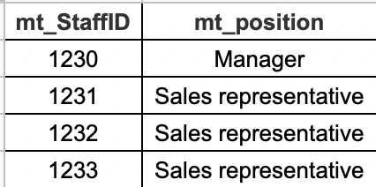

*FD7: mt_StaffID🡪 mt_position*

**Entities in 3NF:**

1. **Marketing Team(mt_BranchNo, PropertyID(fk), mt_StaffID)**

**FD7: mt_BranchNo, propertyID→ mt_StaffID**

1. **Mkt_Staff(mt_StaffID, mt_position)**
2. **FD8: mt_StaffID→ mt_position**

1. IT Office(it_BranchNo, it_streetAddress, City, State, Zip code ,it_ContactNo, it_StaffID, projectType, it_position)



**Key: it_BranchNo,it_StaffID**

*FD1: it_branchNo→ it_streetAddress, City, State, Zip code ,it_ContactNo,*

*FD2: it_StaffID→ projectType, it_position*

**1NF**: since the columns have atomic values and have consistent data types we can say it’s in 1NF

**2NF** : Partial dependency in FD1 and FD2

Making new entity: IT Branch Loc and IT Staff

Entities in 2NF :

1. IT Staff( it_staffID, projectType, it_position, it_BranchNo(fk))

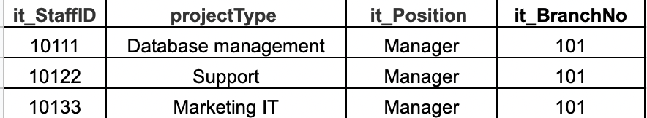

*FD3: it_StaffID→ projectType, it_position, it_BranchNo*

1. IT Branch Loc(it_branchNo, it_streetAddress, City, State, Zip code, it_ContactNo)

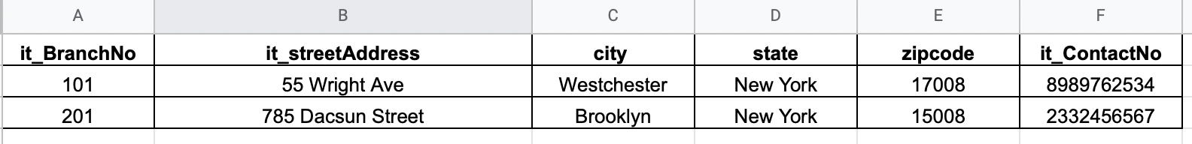

*FD4 : it_branchNo 🡪, it_streetAddress, City, State, Zip code, it_ContactNo*

**3NF**:

No transitive dependency so they are already in 3NF

1. Customer(CustomerID, c_Name, c_DOB, c_Gender, c_streetAddress, city, state, pincode)

**Key : CustomerID**

*FD1: CustomerID→ c_Name, c_DOB, c_Gender, c_Address*

**1NF**: since the columns have atomic values and have consistent data types we can say it’s in 1NF

**2NF and 3NF:**

No partial dependencies and no transitive dependencies

1. Broker(BrokerID, Name)

**Key: BrokerID**

*FD1: BrokerID→ Name*

**1NF**: since the columns have atomic values and have consistent data types we can say it’s in 1NF

**2NF and 3NF:**

No partial dependencies and no transitive dependencies

1. Appointment(AppointmentID, Date, Time, CustomerID(fk))

**Key: AppointmentID**

*FD1: AppointmentID→ Date, Time, CustomerID*

**1NF:** since the columns have atomic values and have consistent data types we can say it’s in 1NF

**2NF and 3NF:**

No partial dependencies and no transitive dependencies

1. Property(PropertyID, streetAddress, City, State, Pincode, brokerID, year_built)

**Key: PropertyID**

*FD1: PropertyID→ streetAddress,City, State, Pincode, brokerID, year_built*

**1NF**: since the columns have atomic values and have consistent data types we can say it’s in 1NF

**2NF and 3NF:**

no partial dependencies or transitive dependencies

1. Legal Team (l_staffID , l_ProjectNo ,contractID (fk) , backgroundCheck)

**Key: I_staffID**

*FD1: I_staffID → l_ProjectNo*

*FD2: contractID (fk) → backgroundCheck*

**1NF** : all column values are atomic and consistent in 1NF

**2NF and 3NF** : no partial or transitive dependencies.

1. Contract(contractID, Guarantor, insurance, startDate, endDate, duration, tenantID(fk), propertyID(fk), securityDeposit, rent)

**Key: contractID**

*FD1: contractID→ startDate, endDate, duration, tenantID(fk)*

*FD2: propertyID→ securityDeposit, rent*

**1NF**: since the columns have atomic values and have consistent data types we can say it’s in 1NF

**2NF and 3NF:** no partial dependencies or transitive dependencies

1. Tenant(TenantID, t_Name, t_DOB, phoneNo, t_Gender, t_streetAddress,city, state, zipcode, propertyID(fk))

**Key: TenantID**

*FD1: TenantID→ t_Name, t_DOB, phoneNo, t_Gender, t_streetAddress,city, state, zipcode, propertyID(fk)*

1. Finance(f_StaffID,f_ProjectNo, loanID(fk),contractID(fk),securityDeposit, rent)

**Key: f_StaffID**

*FD1: f_StaffID → f_ProjectNo, loanID, l_amount, contractID, securityDeposit*

**1NF**: Meets the definition of a relation

**2NF and 3NF:** No partial or transitive dependencies

1. Bank(bankID, b_streetAddress, city, state, zipcode b_staffID)

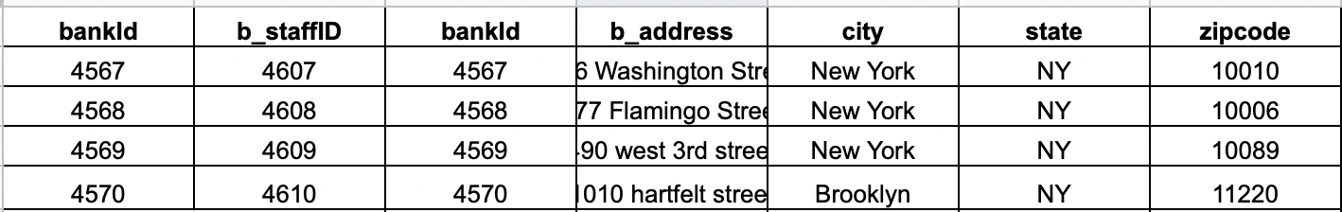

**Key: bankID, bstaffID**

*FD1:bankID→ b_streetAddress, city, state, zipcode*

*FD2: bankID→ bstaffID*

**1NF**: Meets the definition of a relation

**2NF:** Partial dependency exists

2 new entities created

1. Bank_staff(bankID, bstaffID)

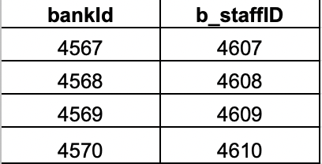

*FD3: bankID→ bstaffID*

1. Bank_branch(bankID, b_streetAddress, city, state, zipcode)



*FD4: bankID 🡪 b_streetAddress, city, state, zipcode*

1. Loan(LoanID, contractID, l_amount, l_startDate,l_endDate, interest, l_collateral, bankID(fk))

**Key: LoanID, bankID**

*FD1: LoanID, bankID→ contractID, l_amount, l_startDate,l_endDate, interest, l_collateral*

The entity is in 3NF

1. Maintenance (complaintID, complaintdate , m_staffID, status)

*FD1 : complaintID, complaintdate, m_staffID, status*

**1NF:** Meets the definition of a relation

**2NF:** No partial dependencies

**3NF:** No transitive dependencies

1. Leasing office (lo_BranchNo, lo_Address,City, state, Pincode, lo_StaffID, contractID)



**Key: lo_BranchNo, lo_StaffID**

*FD1: staffID→ contractID*

*FD2: lo_BranchNo→ lo_Address, City, State, Pincode*

**1NF:** Meets the definition of a relation

2NF: partial dependencies exist

2 new entities Lo_Staff and Lo_Branch

1. Lo_Staff(staffID, contractID)

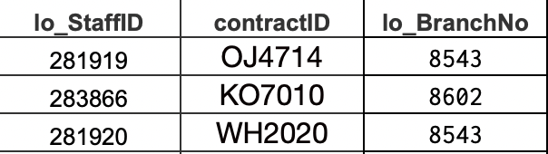

1. Lo_Branch(lo_BranchNo, lo_Address,City,State, Pincode)

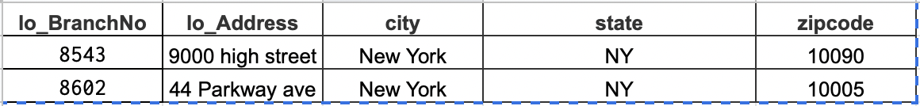

They are now in 3NF

Final relations:

MKT Branch Loc(mt_BranchNo, mt_contactNo, mt_streetAdress, mt_city, mt_state, mt_zipcode)

Marketing Team(mt_BranchNo, PropertyID(fk), mt_StaffID)

Mkt_Staff(mt_StaffID, mt_position)

IT Staff( it_staffID, projectType, it_position)

IT Branch Loc(it_branchNo, it_streetAddress, City, State, Zip code, it_ContactNo)

Customer(CustomerID, c_Name,c_DOB, c_Gender, c_streetAddress, city, state, pincode)

Broker(BrokerID, Name)

Appointment(AppointmentID, Date, Time, CustomerID(fk))

Property(PropertyID, streetAddress, City, State, Pincode, brokerID, year_built)

Legal Team (l_staffID , l_ProjectNo ,contractID (fk) , backgroundCheck)

Contract(contractID, Guarantor, insurance, startDate, endDate, duration, tenantID(fk), propertyID(fk), securityDeposit, rent)

Finance(loanID, l_amount, contractID, securityDeposit,f_projectNo,f_StaffID)

Bank_branch(bankID, b_streetAddress, city, state, zipcode)

Bank_staff(bankID, bstaffID)

Loan(LoanID, contractID, l_amount, l_startDate,l_endDate, interest, l_collateral, bankID(fk))

Maintenance (complaintID, complaintdate , m_staffID, status)

Lo_Staff(staffID, contractID)

Lo_Branch(lo_BranchNo, lo_Address,City,State, Pincode)

Challenges during normalization:

One of the major challenges during normalization was trying to figure out whether to import data to access and then normalize or Normalize in excel and then export to Access. We ended up doing the latter.It was time consuming to look at all the separate entities and to apply rules of normalization one-by-one. To minimize redundancy and ensure absolute primary key dependency of the elements of a table.

Moreover we realized that some attributes that were earlier not present needed to be added, so we appended them to the table and had to modify our ER diagram accordingly.The presence of elements that are related to one another but not partially or transitively dependent on any part of the primary key presented a dilemma. So we sought help from similar questions from the Homework and were able to come up with appropriate solutions.

# Creating the Database

The entire database was created on excel first before importing it to Microsoft Access. We made sure the data we entered was sufficient for each attribute as well as entity. The motive was to keep the data precise and to the point. For example, in the entity Broker, we just added two attributes, BrokerID and name as that was sufficient for the requirement of the dataset. Whereas, in the Tenant entity we added more than 5 attributes. It is necessary for the entity to have details like, name, dob, phone number and address to create valuable and resourceful information. After we added data in excel and then we eventually imported it to Access.

Creating tables using SQL:

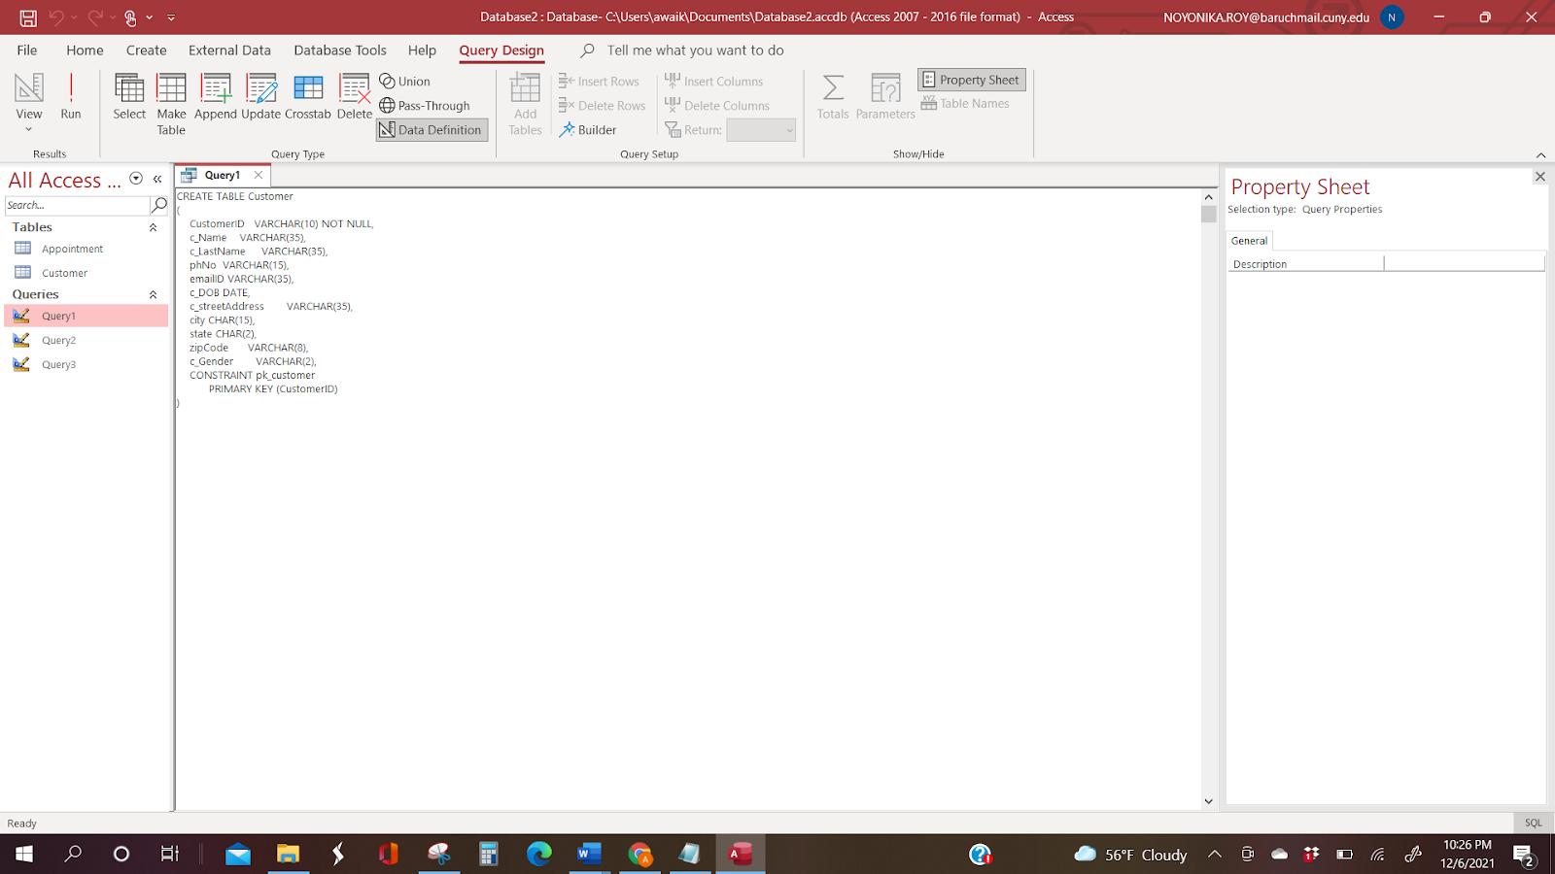

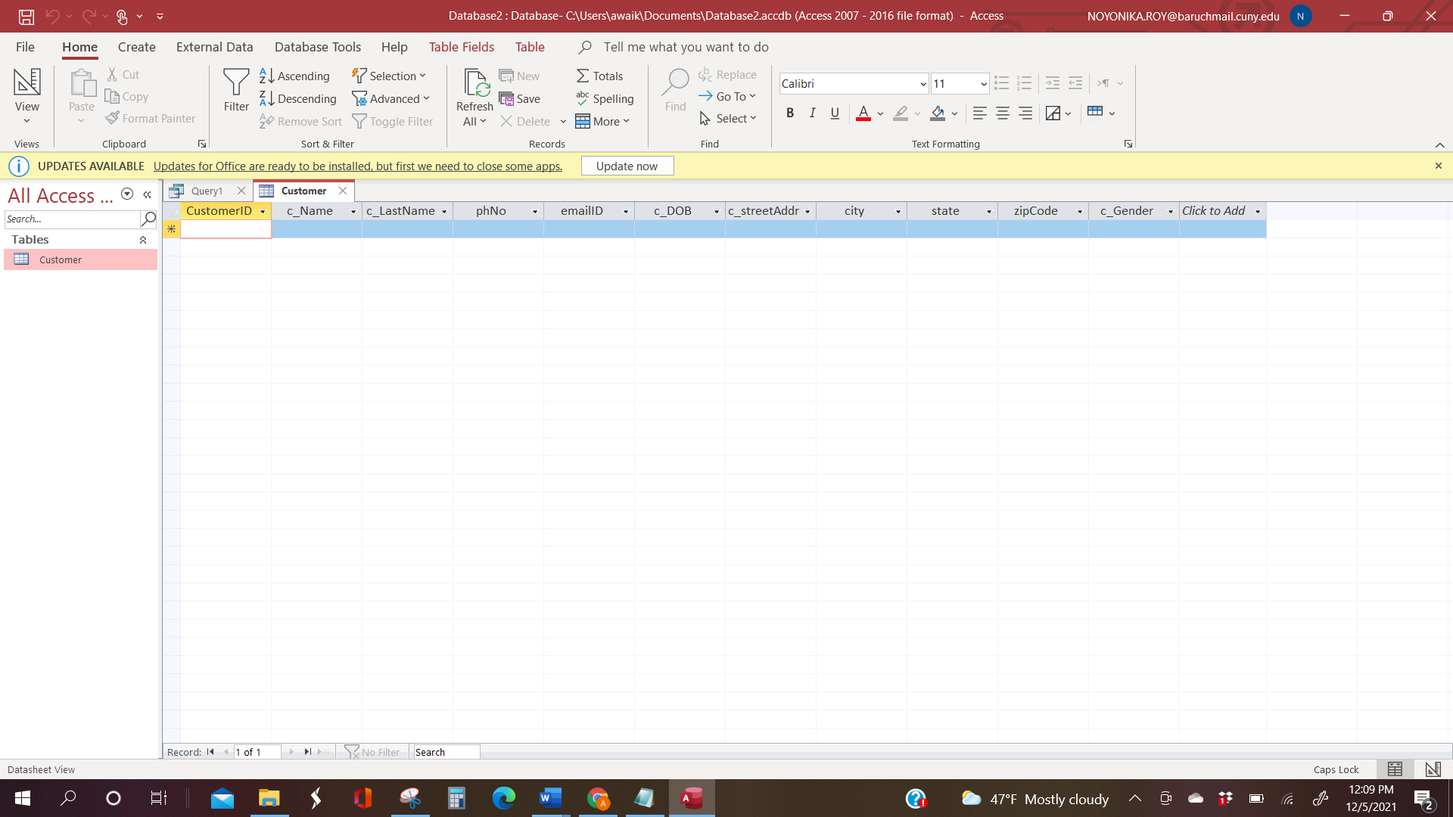

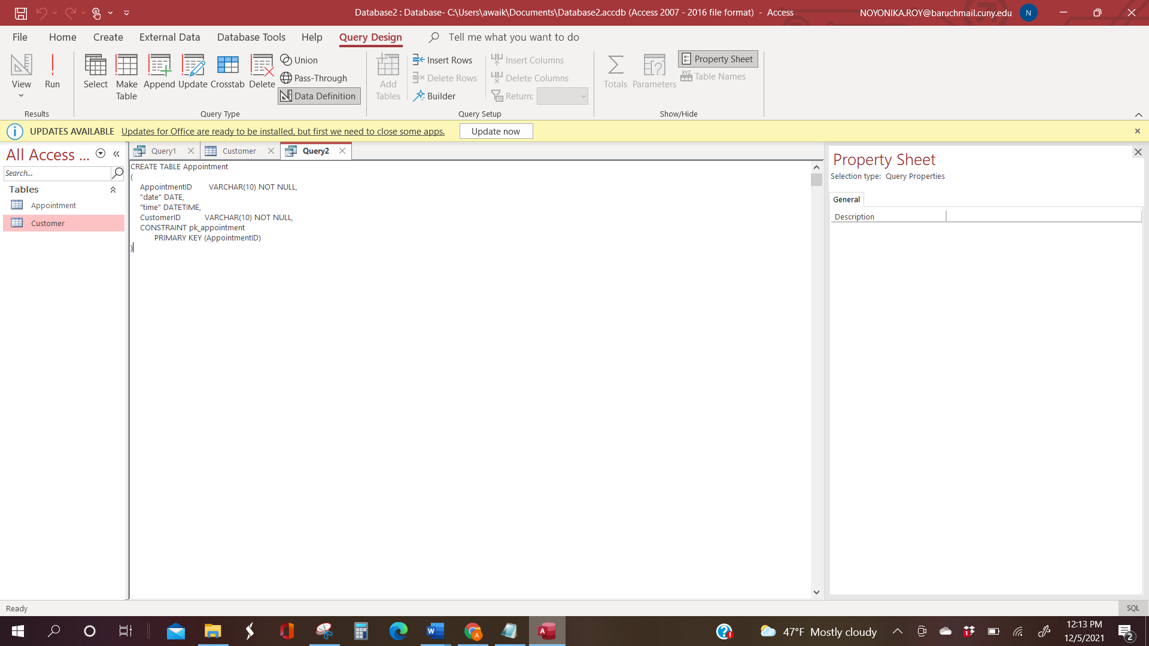

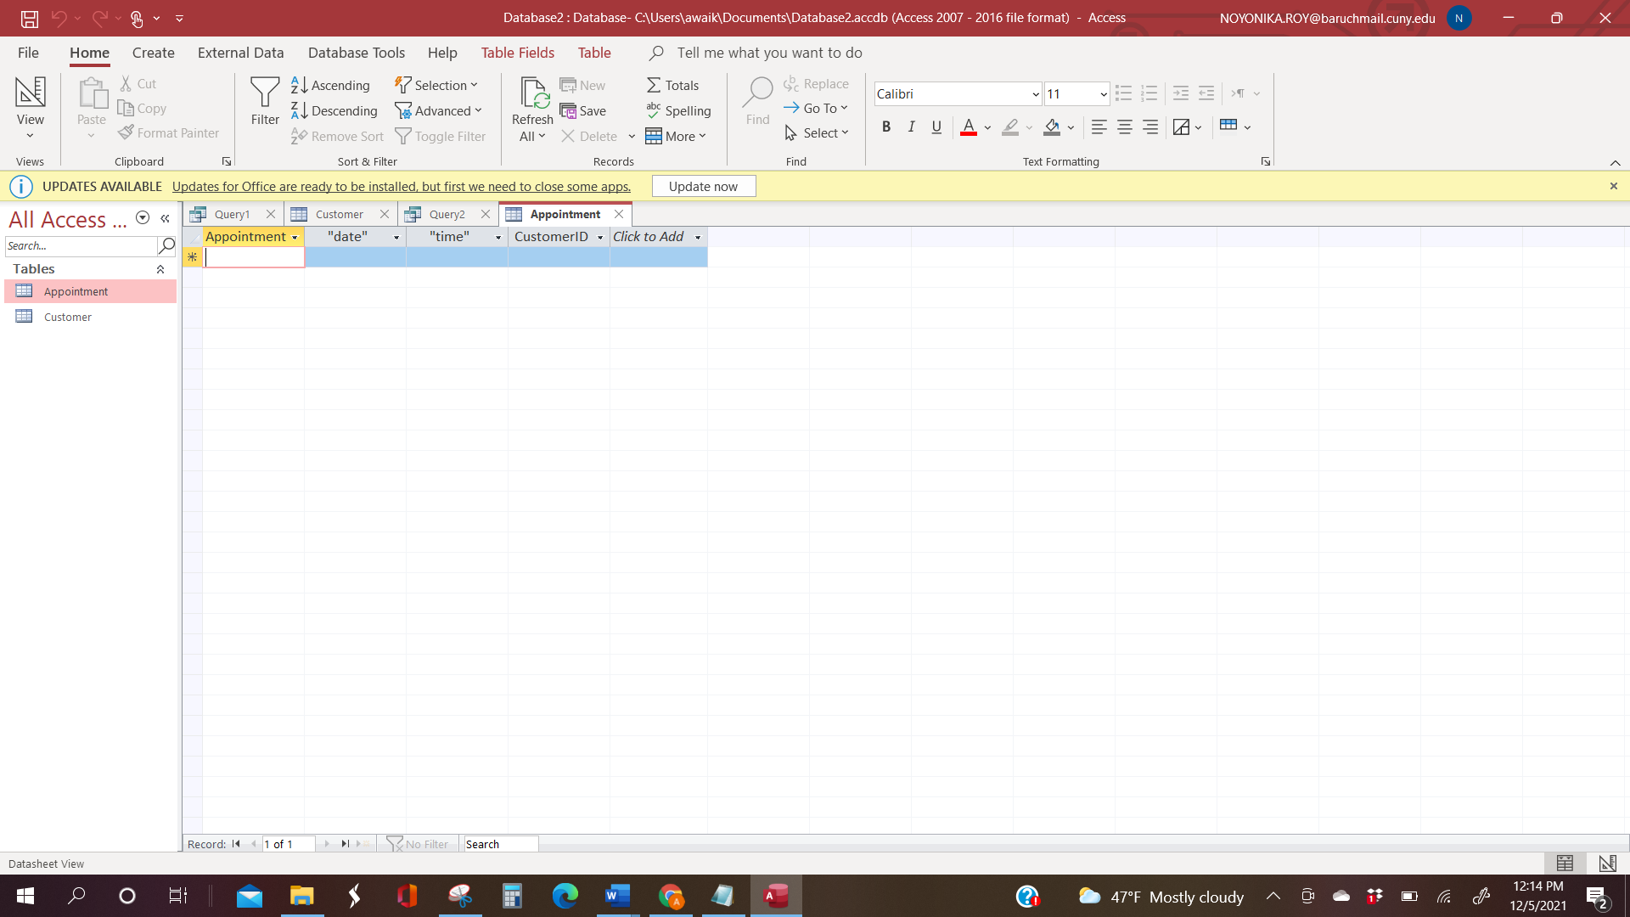

Our actual database in MS Access:

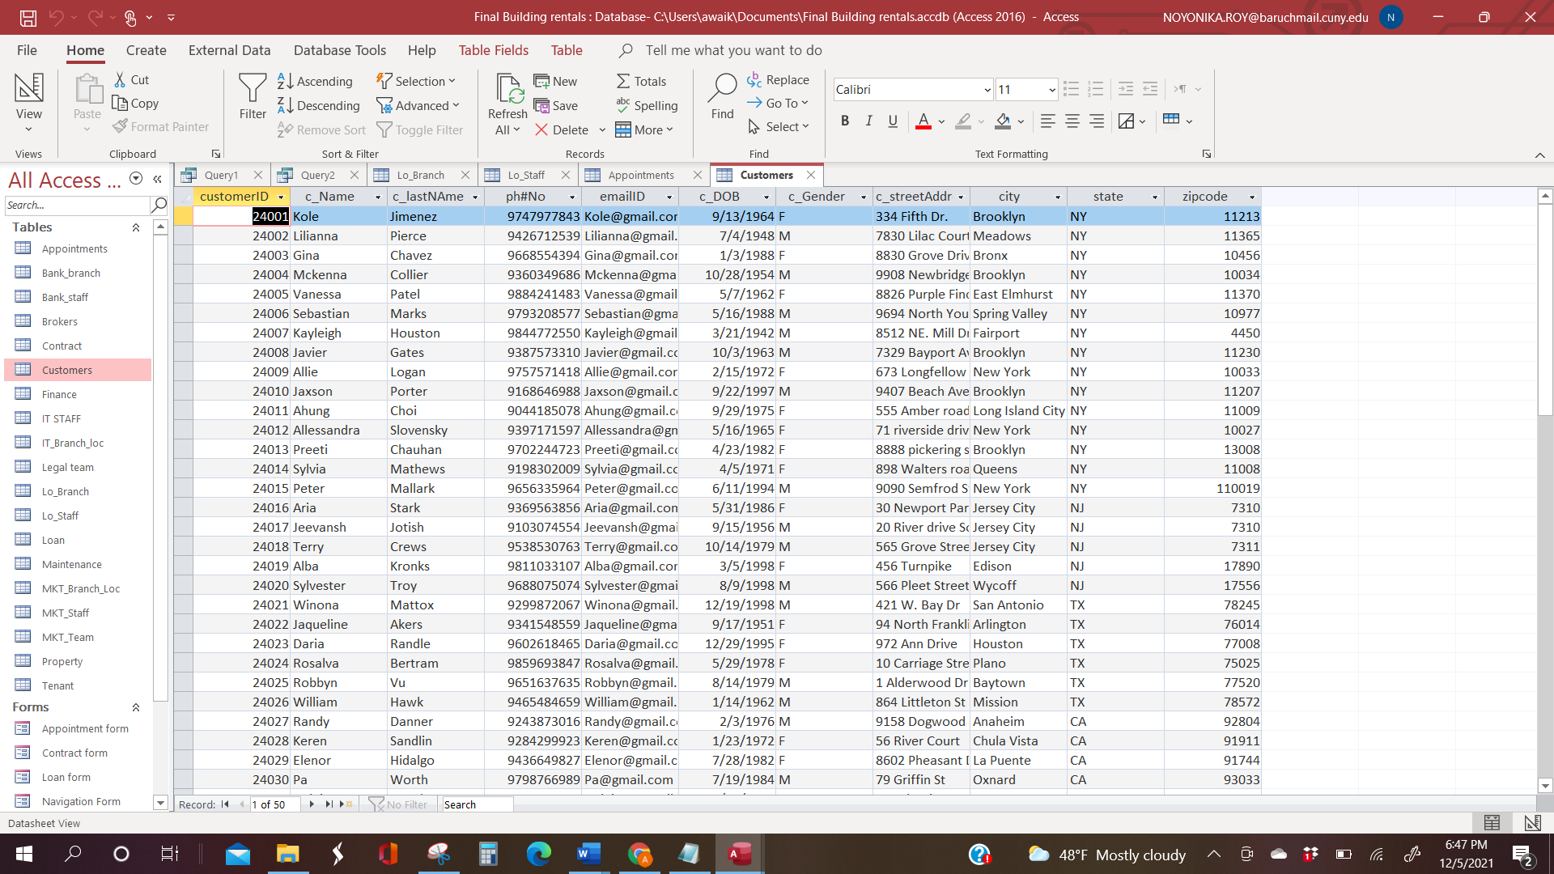

Datatypes:

* In columns such as Address, Zip code and city, “Varchar” Datatype is used to store character strings of variable length but maximum of set length is specified.
* For the State column “Char(2)” datatype is used to store single characters such as letters, digits and symbols etc.
* Unique columns are assigned as Primary key in each table and Foreign key Constraints are defined with meaningful names such as “PropertyID(fk)”.
* Primary keys and Foreign keys have the same datatype “ int(15) ” in all the tables. It is used to store a unique ID which is in Integer type.
* Date (date : type = date)” datatype is used to declare variables for storing date tokens in fields like DOB and Date.
* Time (time : type = time)” datatype is used to declare variables for time tokens in hours, minutes, seconds, optional fractions of seconds and timezones.

Foreign keys assignment using SQL code:

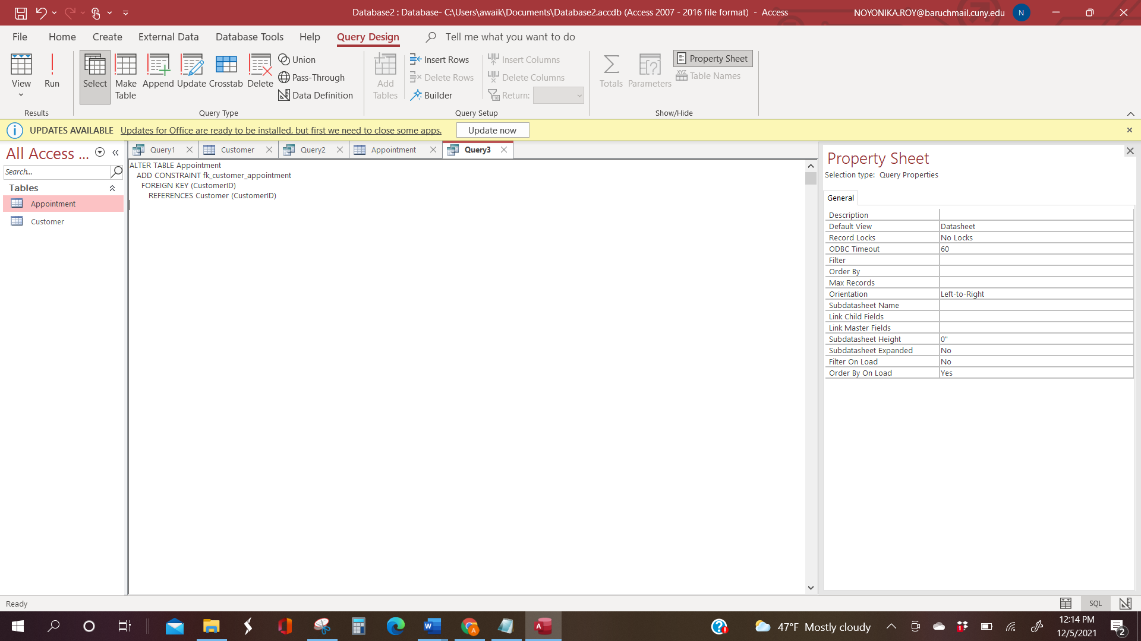

This code results in a relationship as shown below:

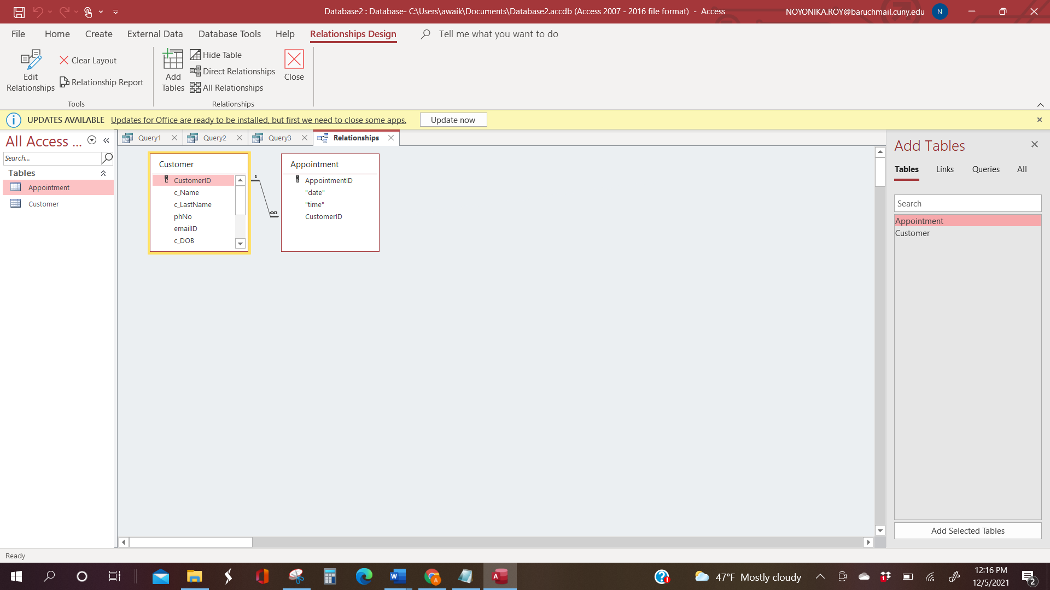

# RELATIONSHIPS

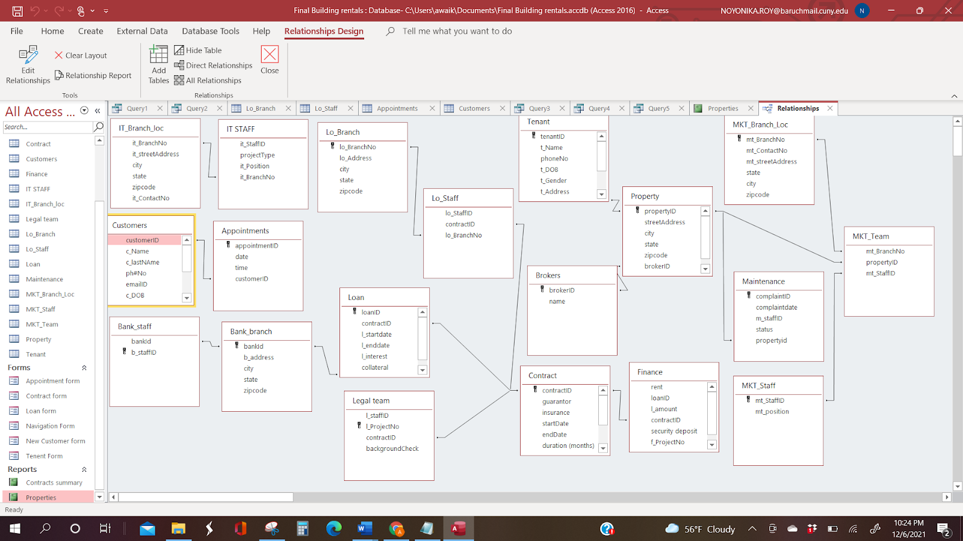

# Database Application

QUERIES:

1)

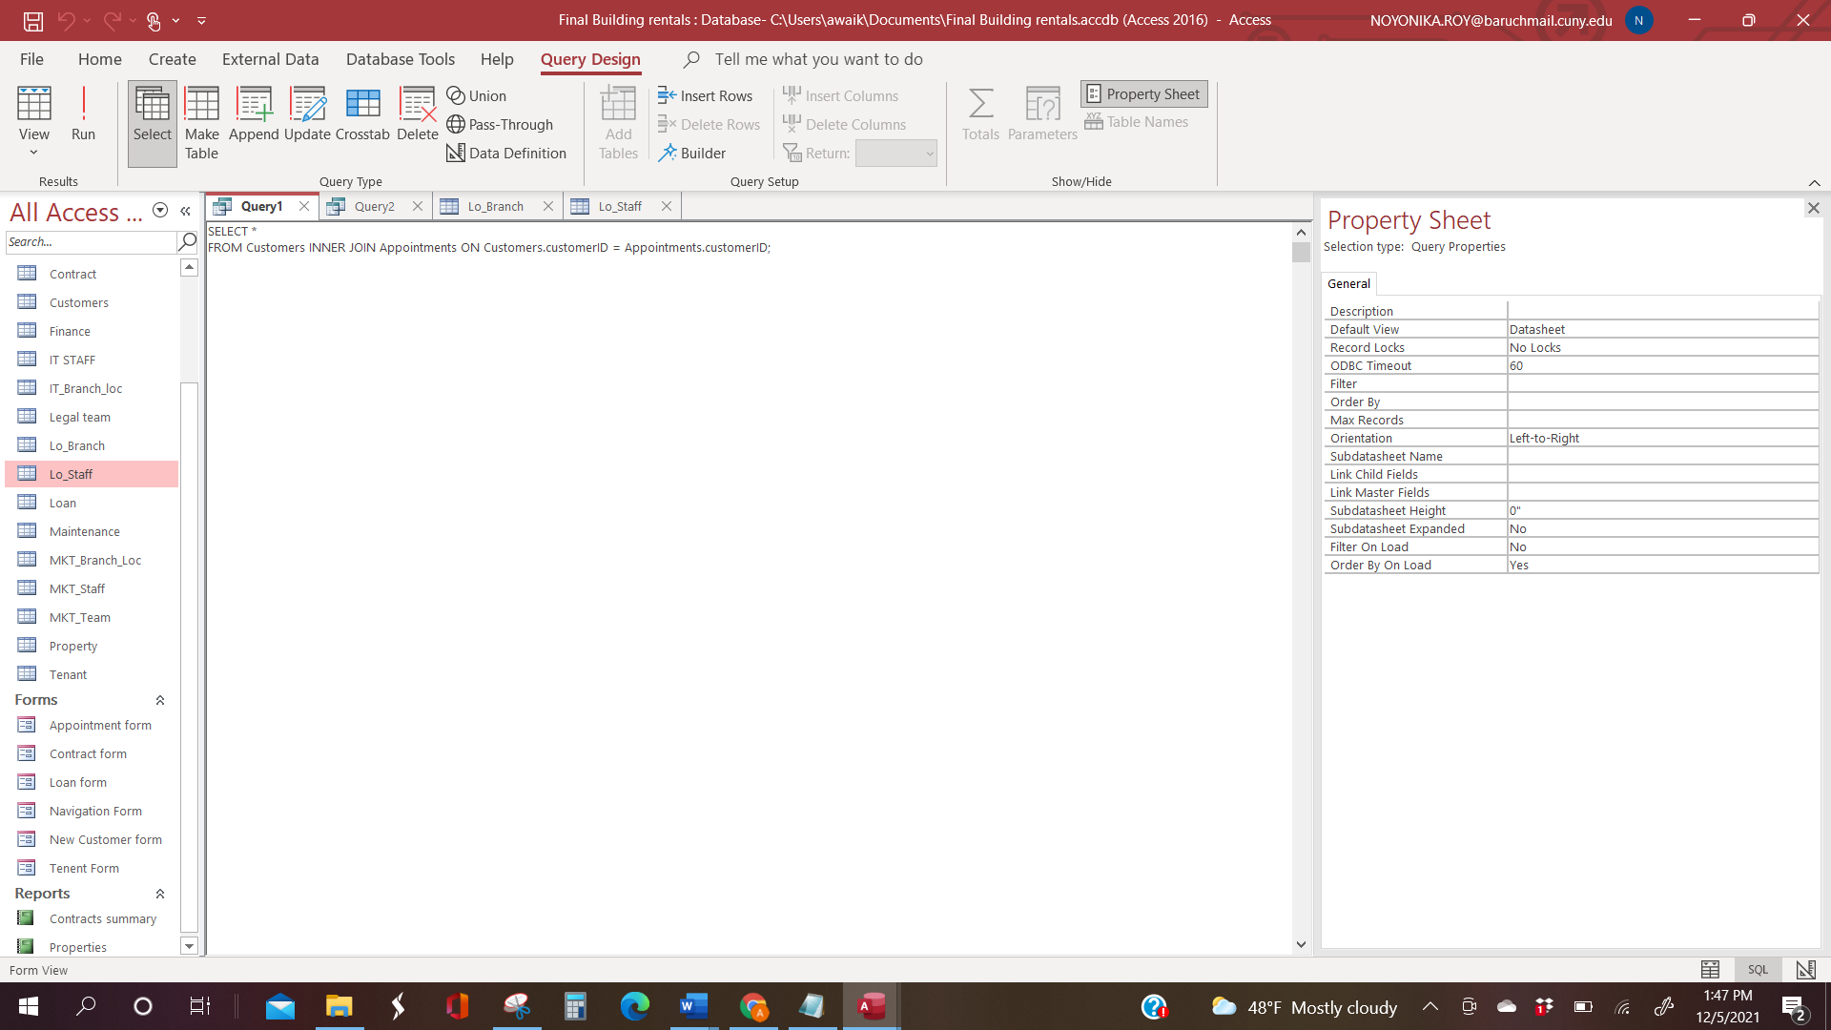

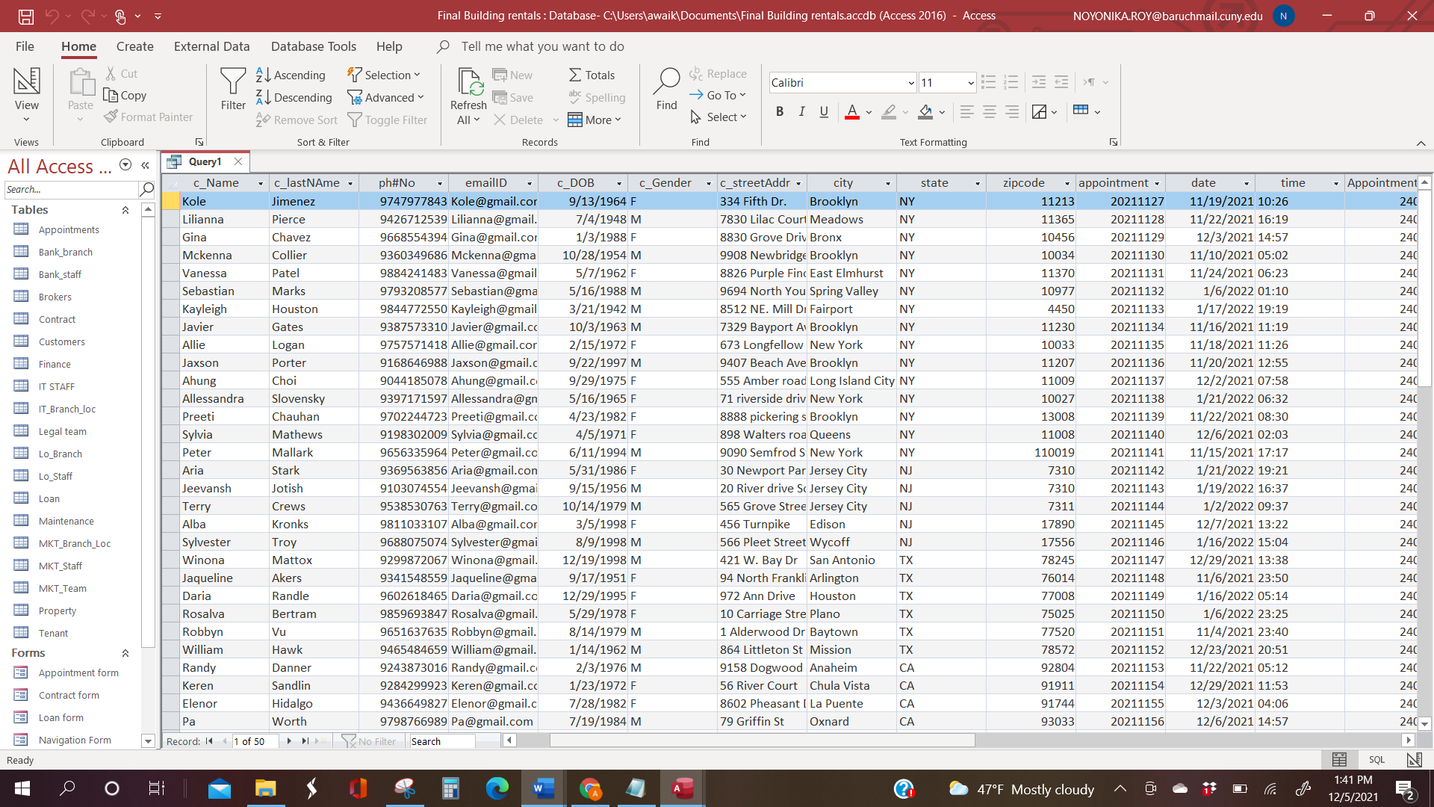

2)

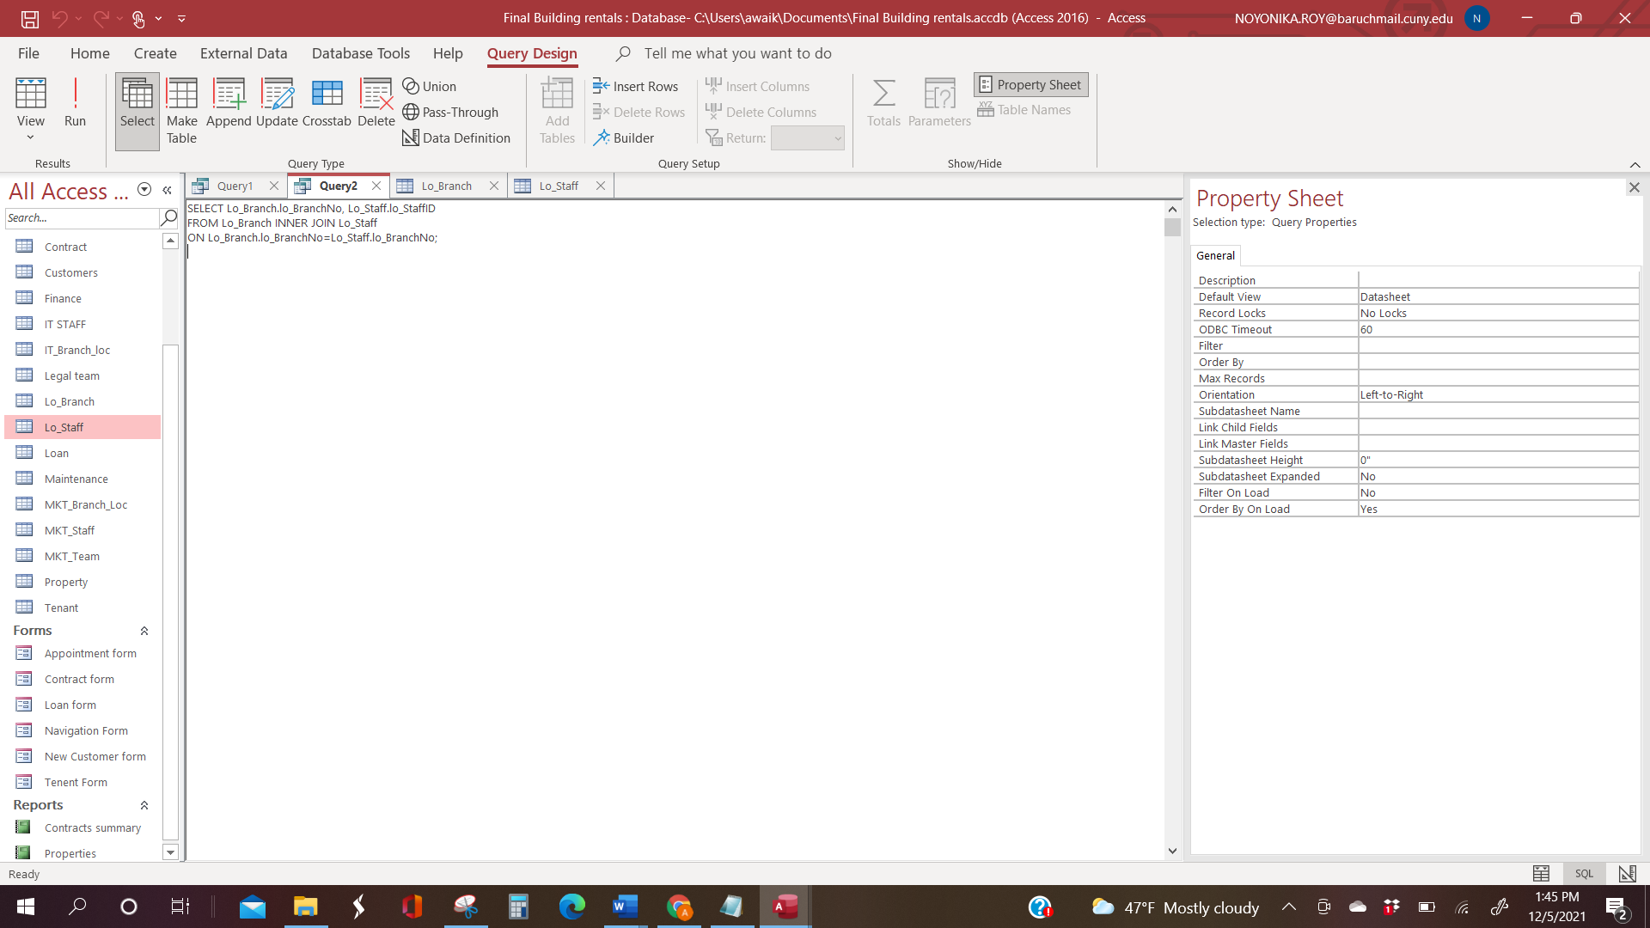

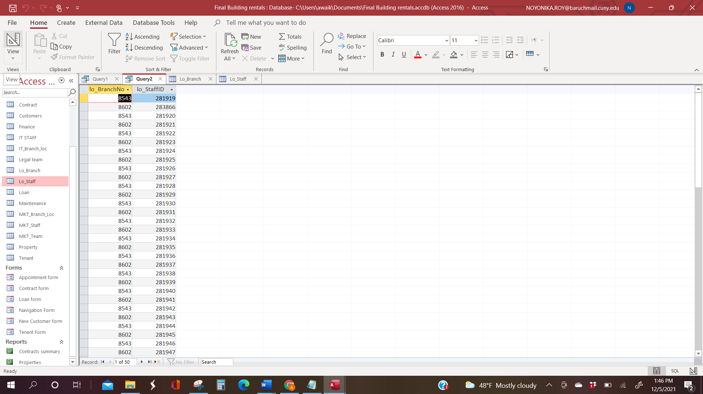

3)

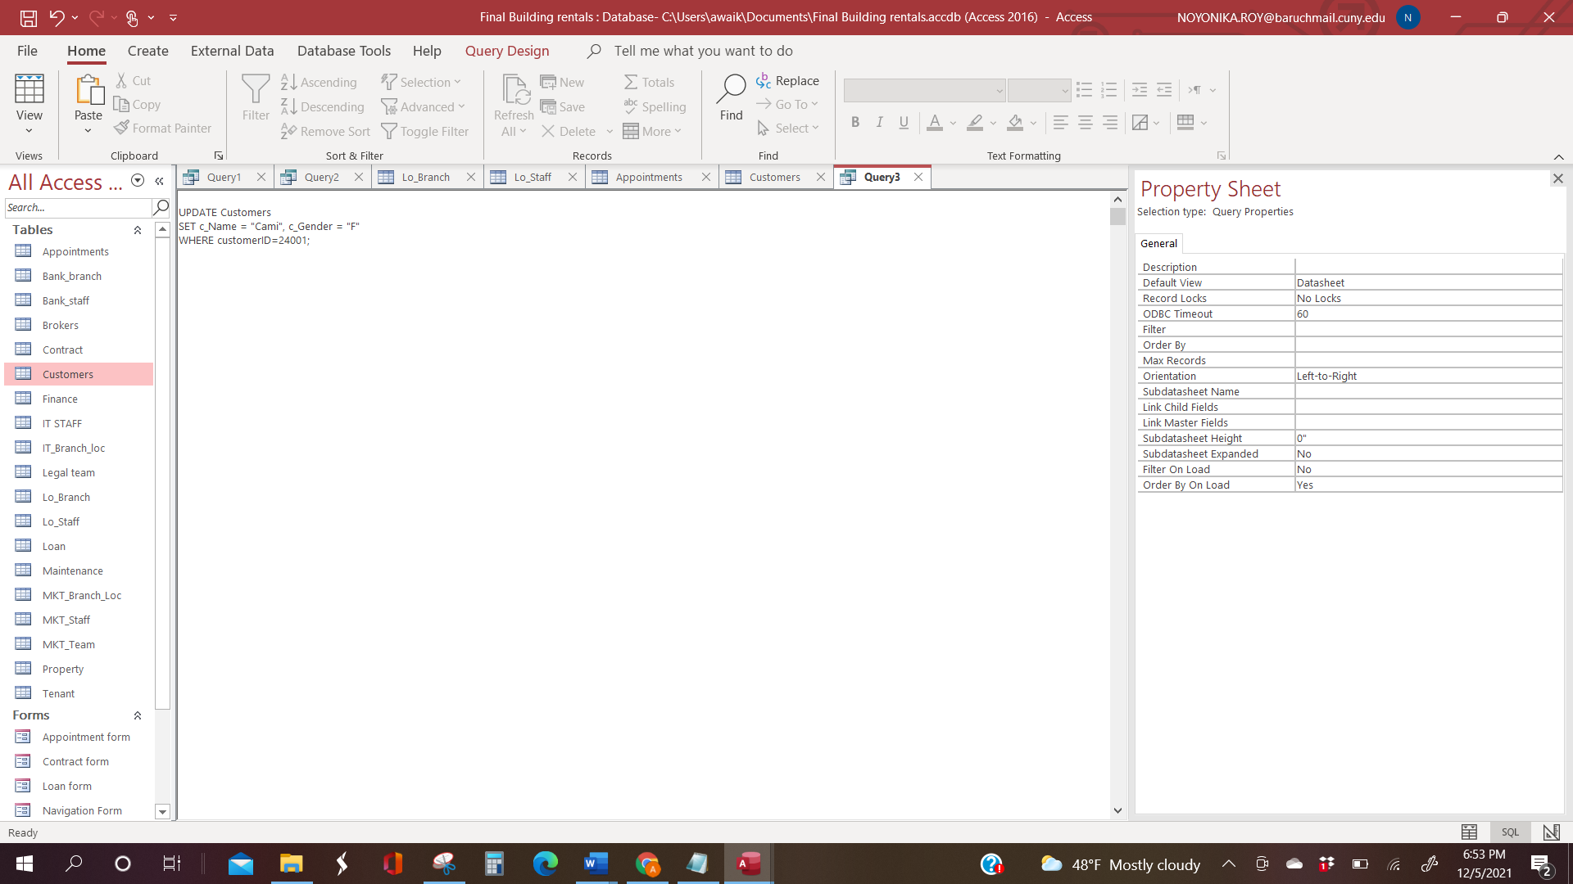

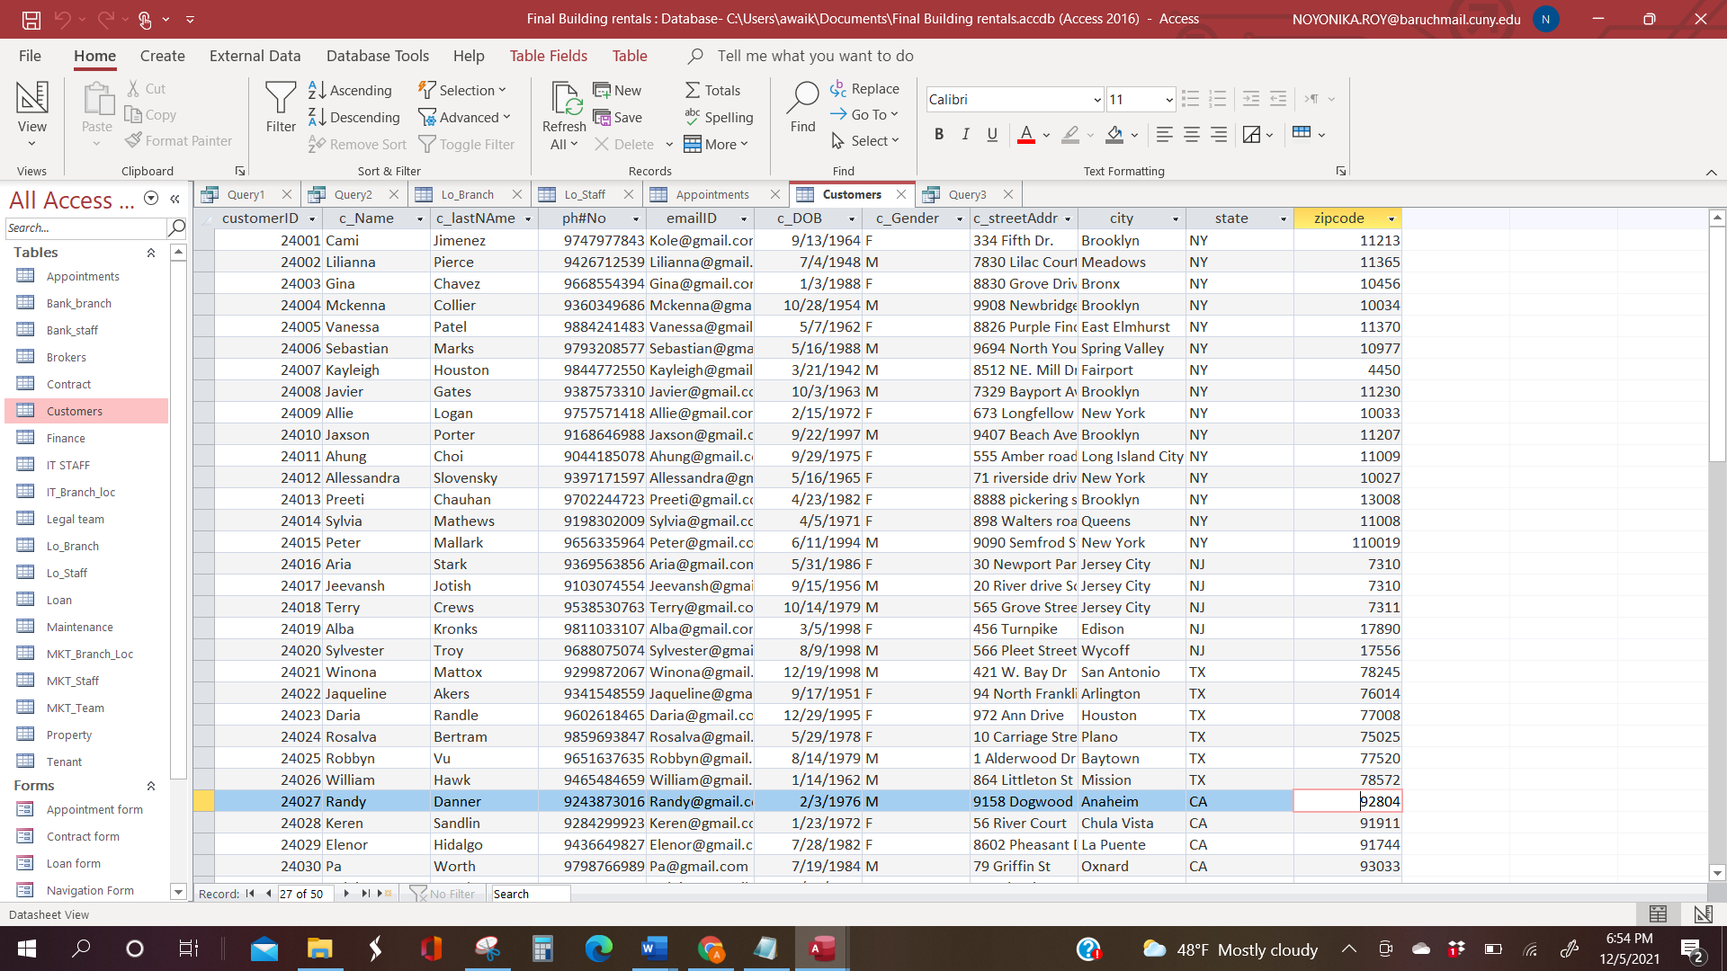

4)

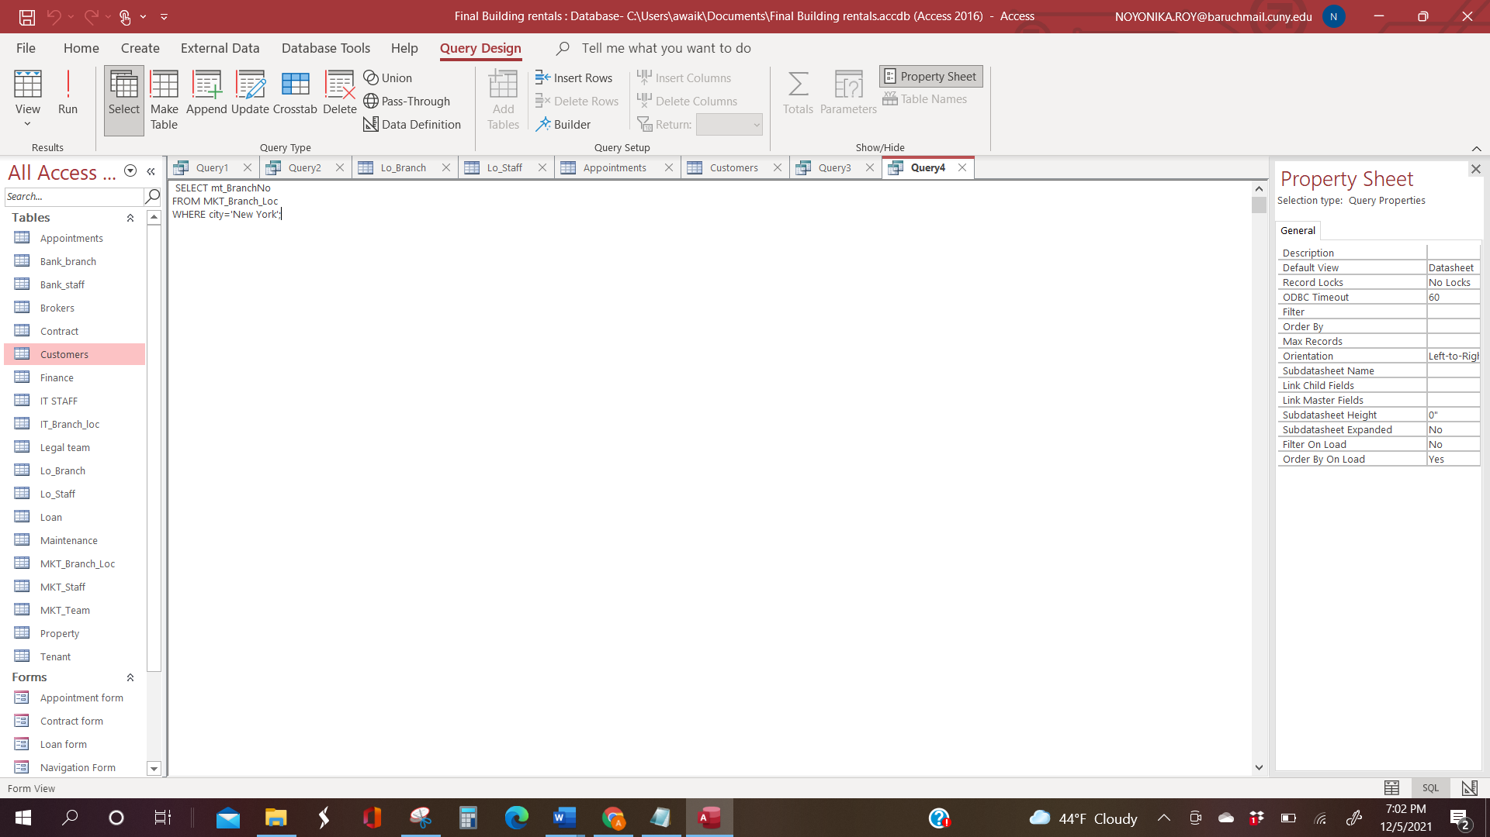

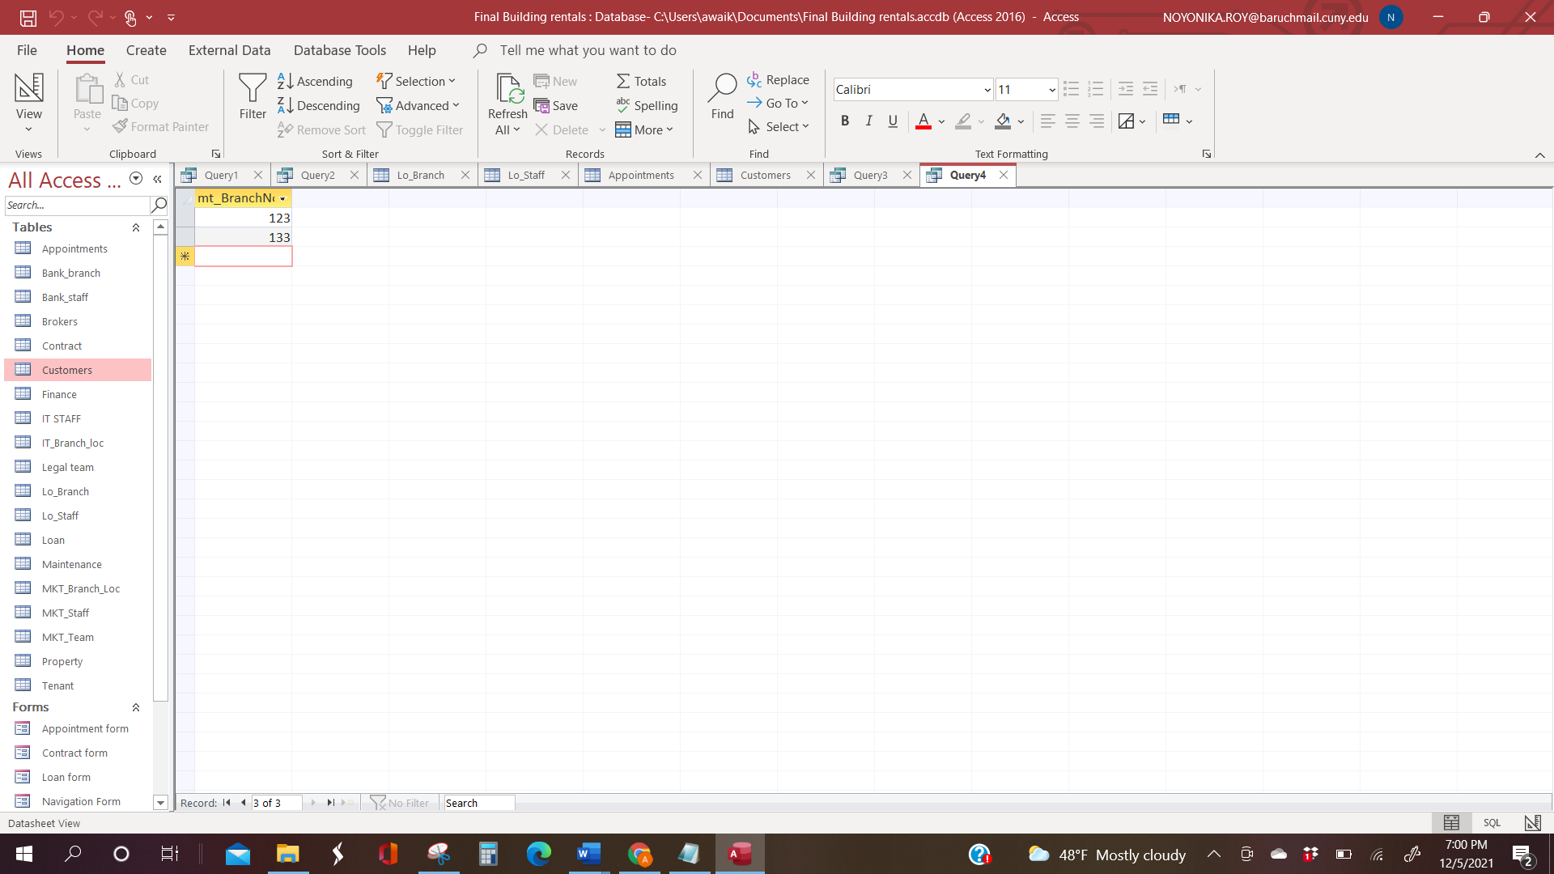

5) Design view of a query:

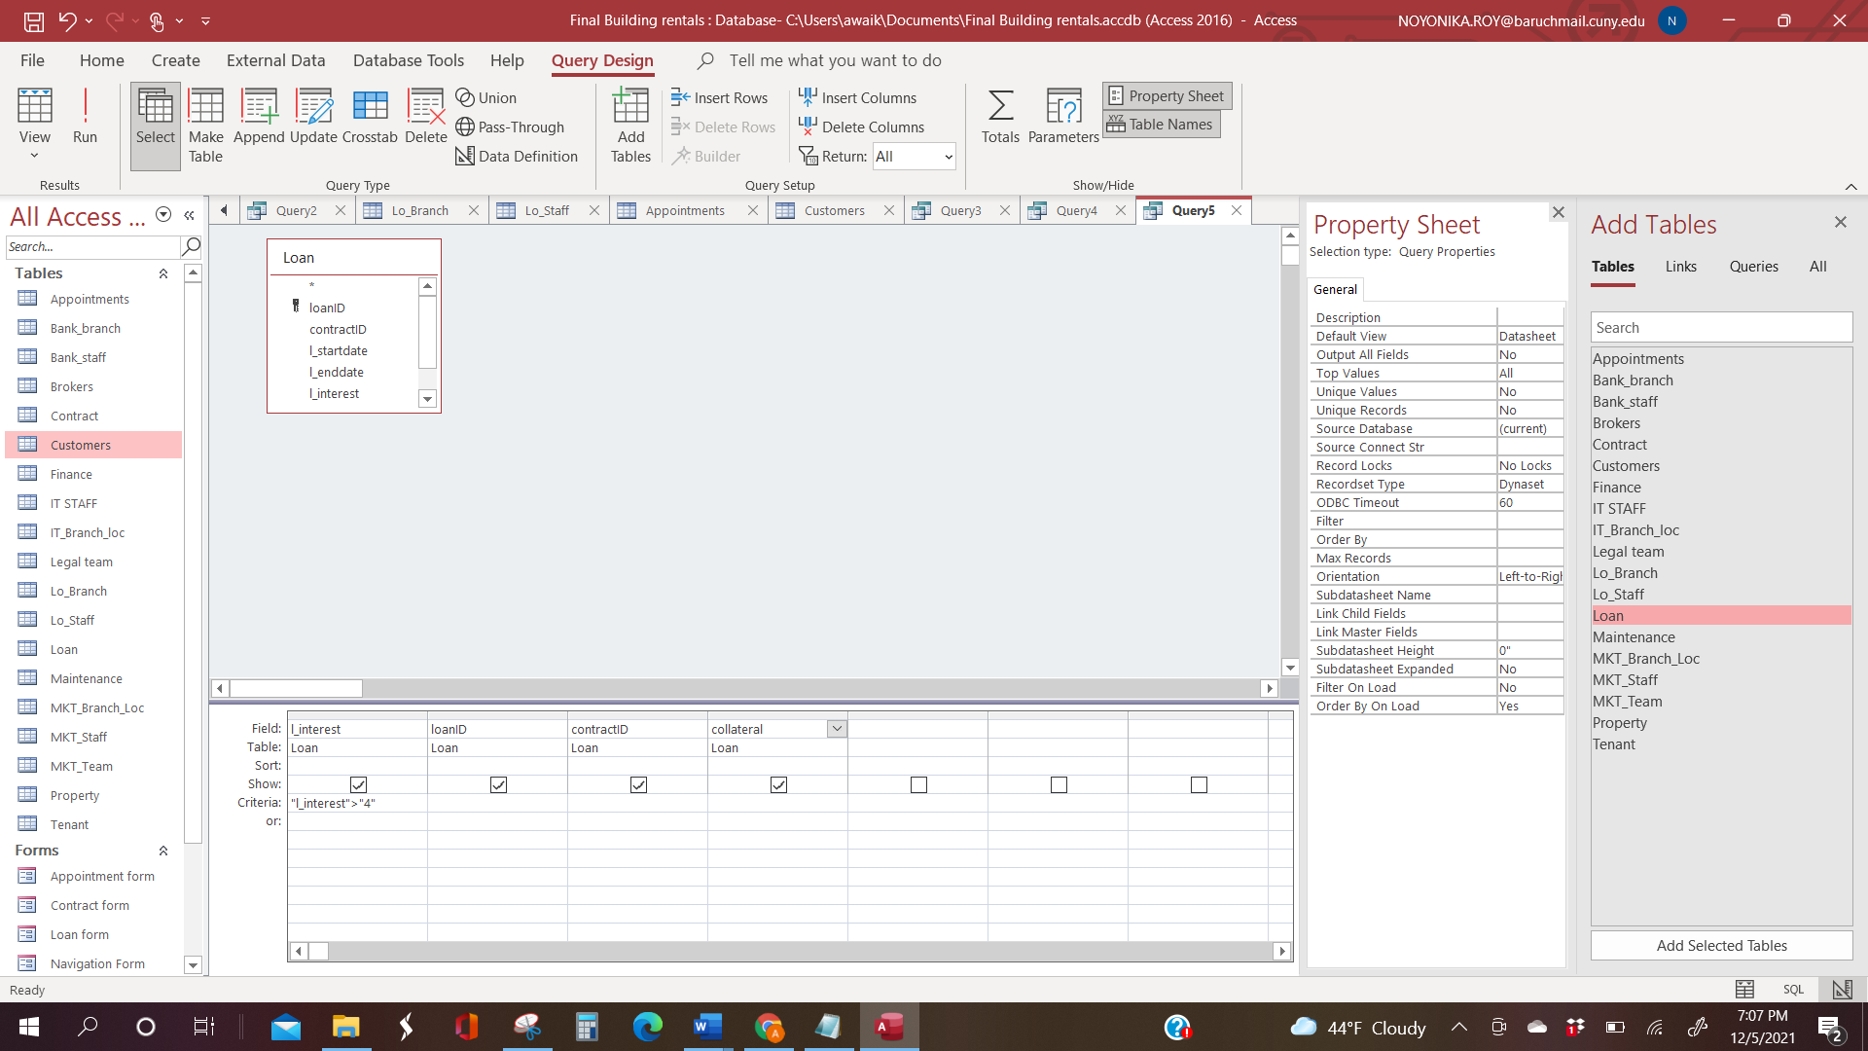

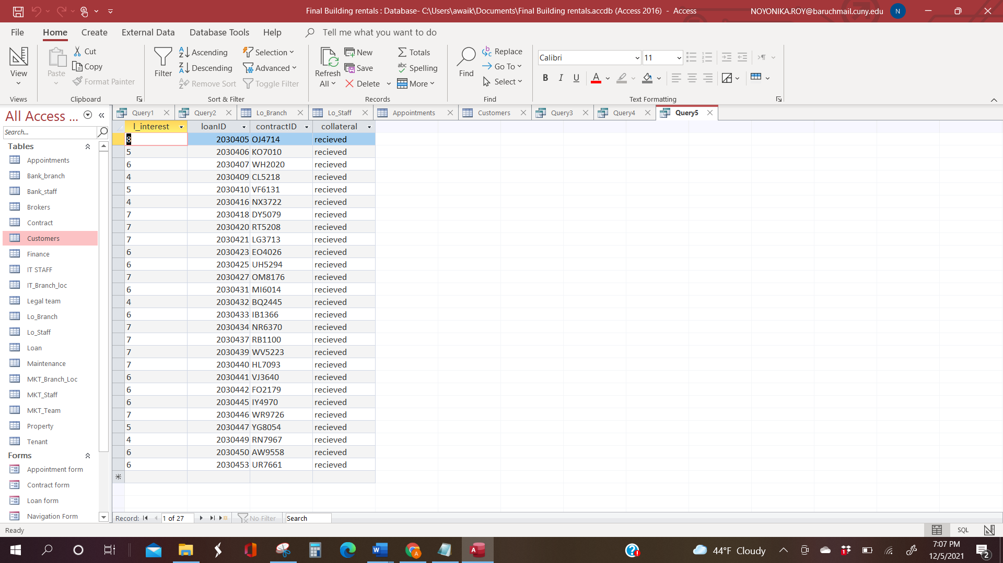

FORMS:

1)Navigation form allows one to navigate between forms and is the main menu when the database opens up

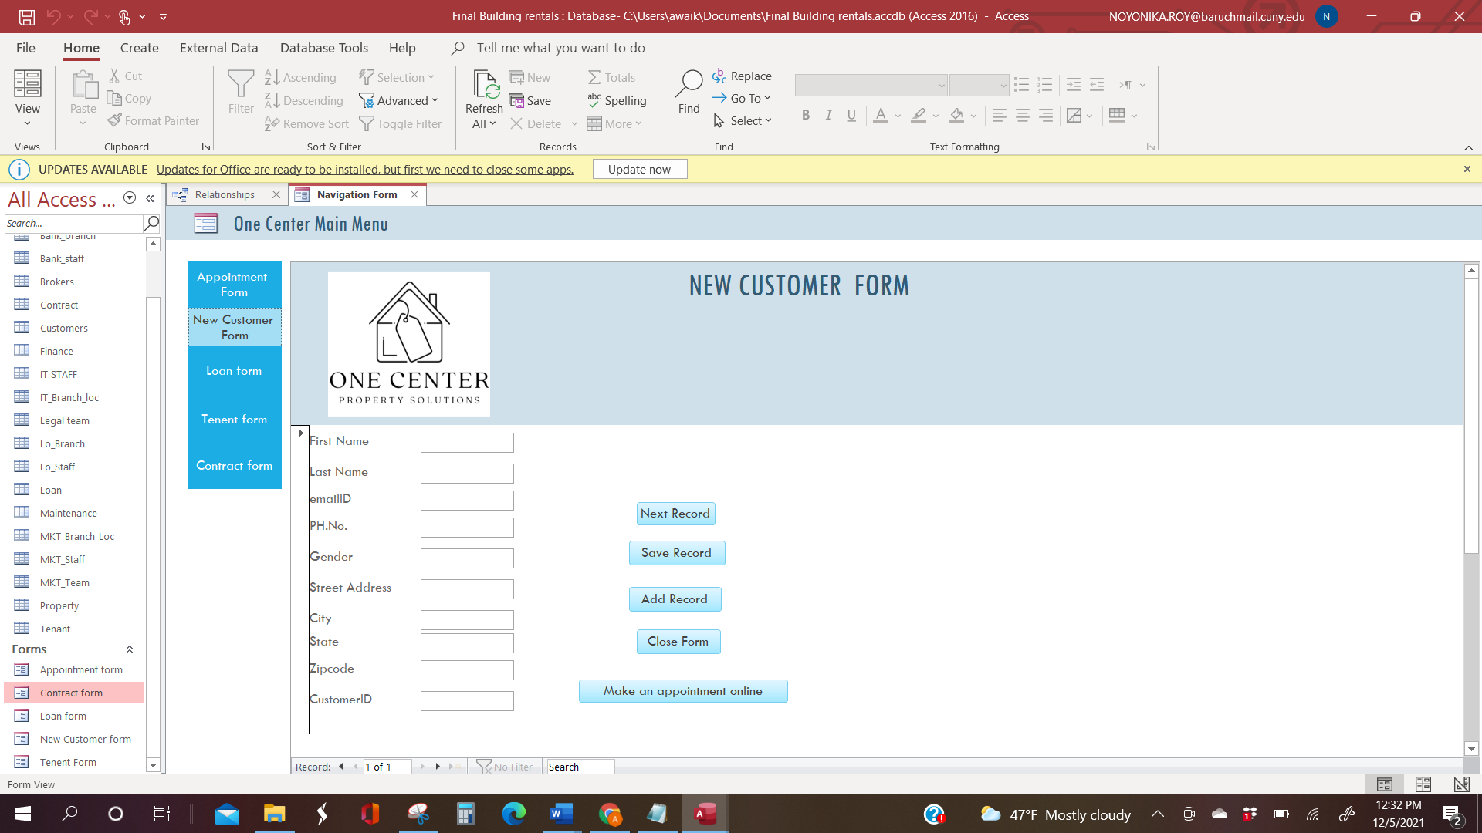

We created a few examples pf forms that allow one to add new records into tables.

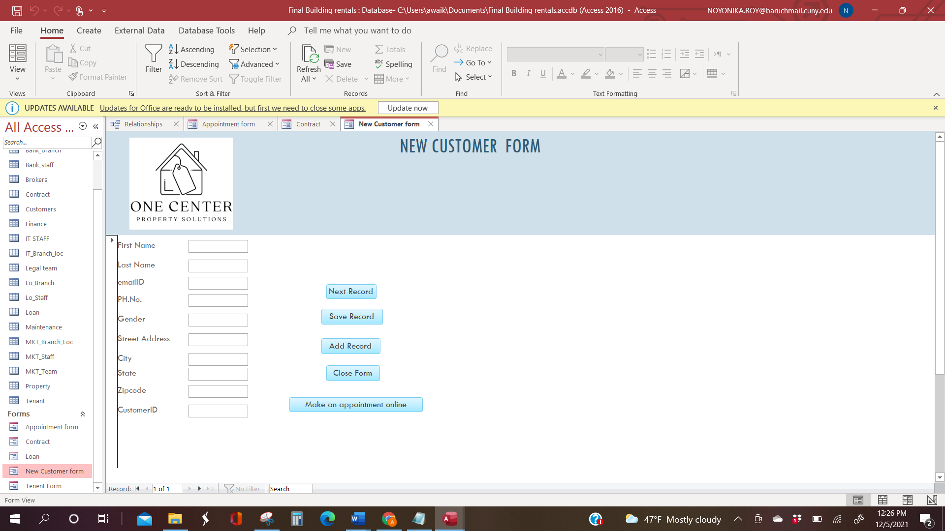

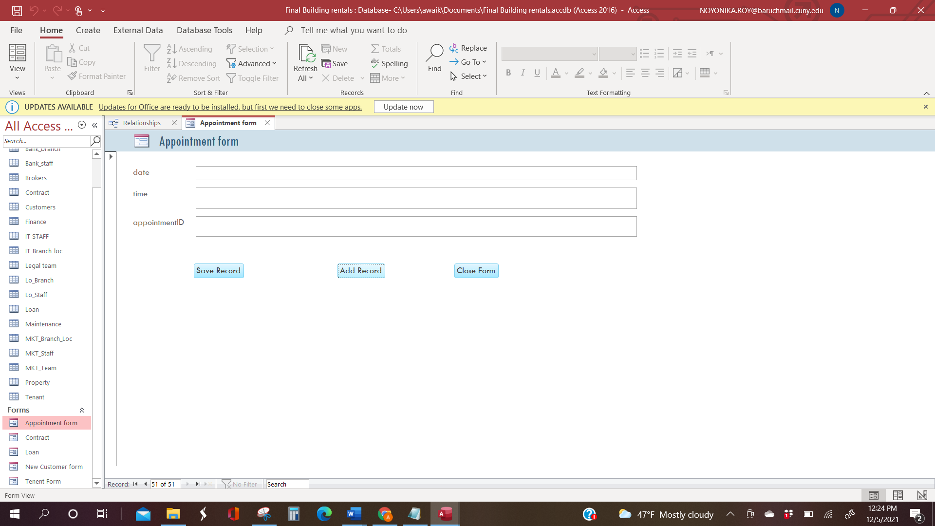

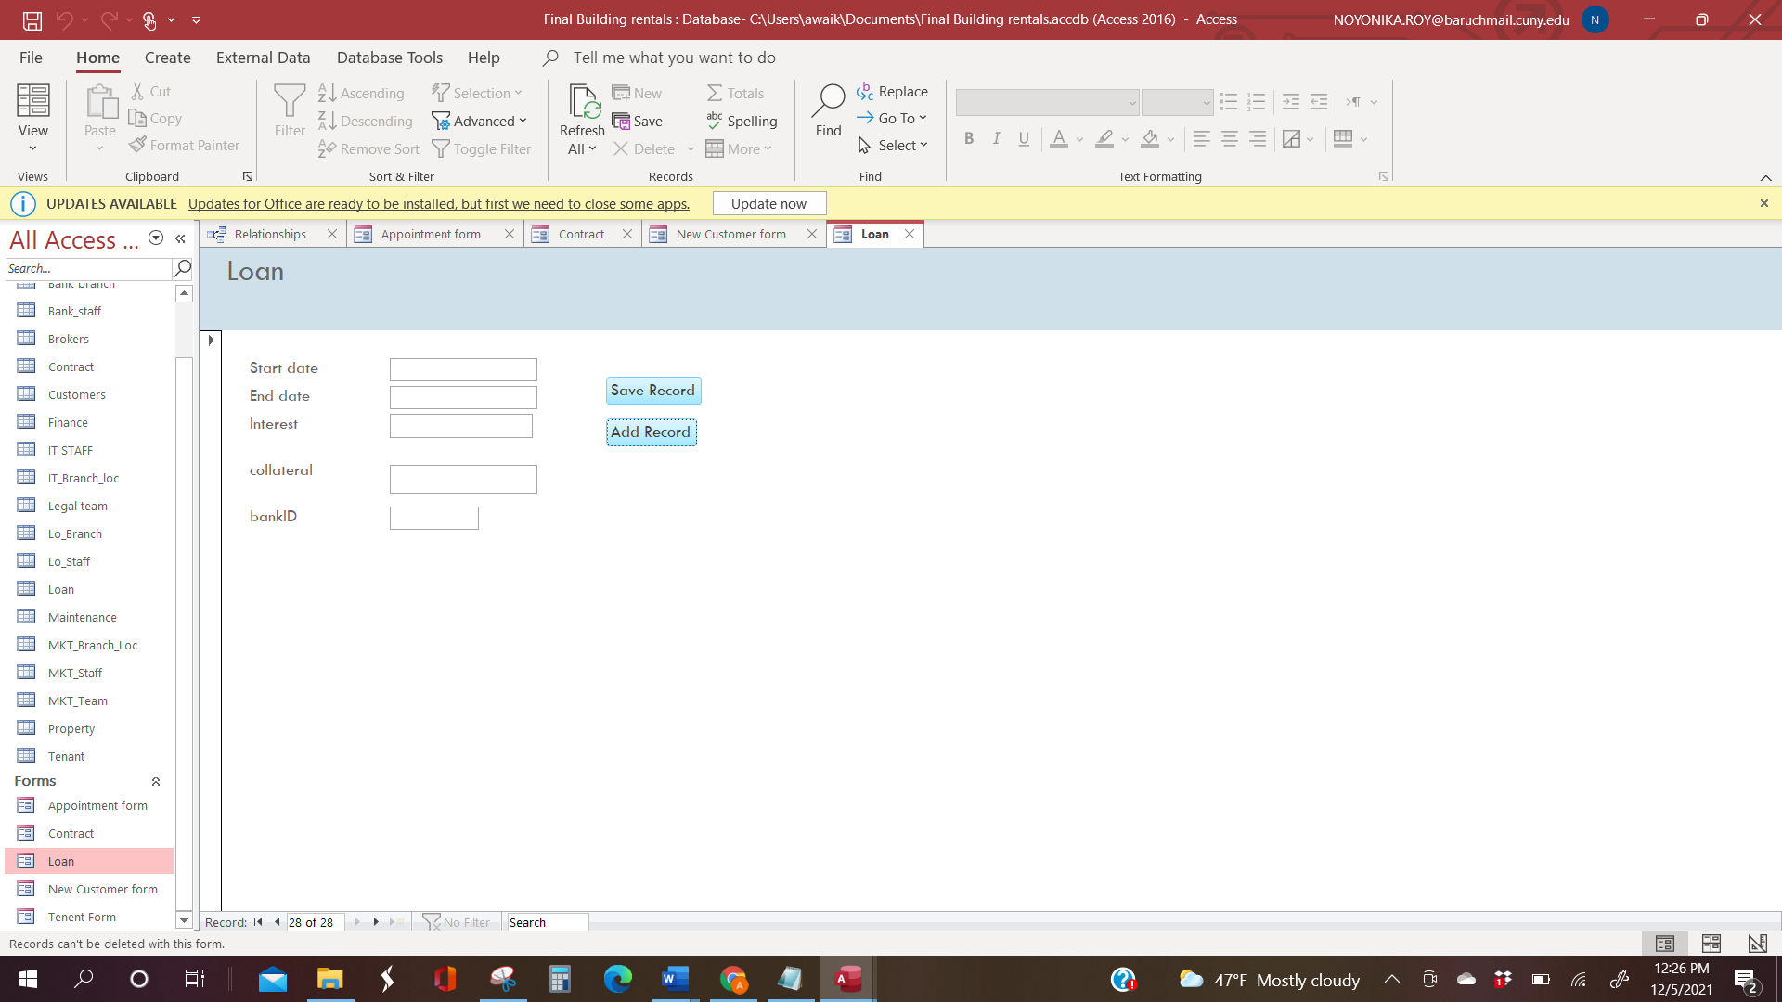

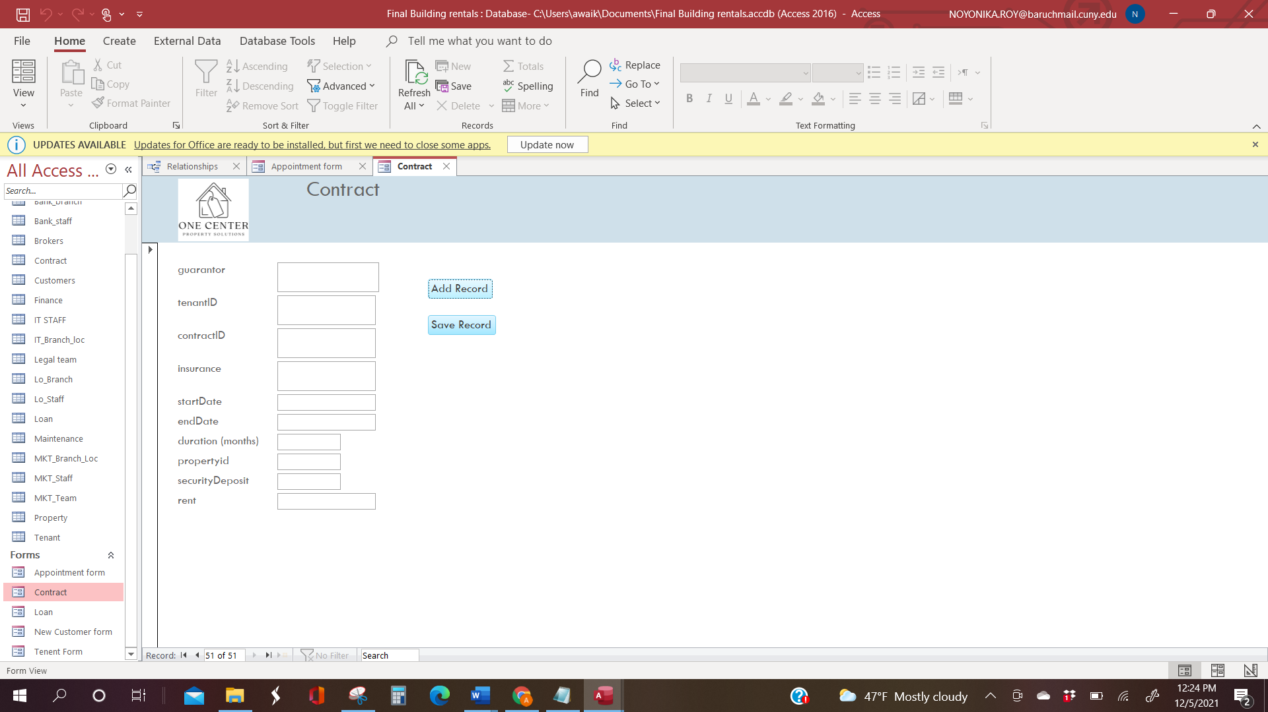

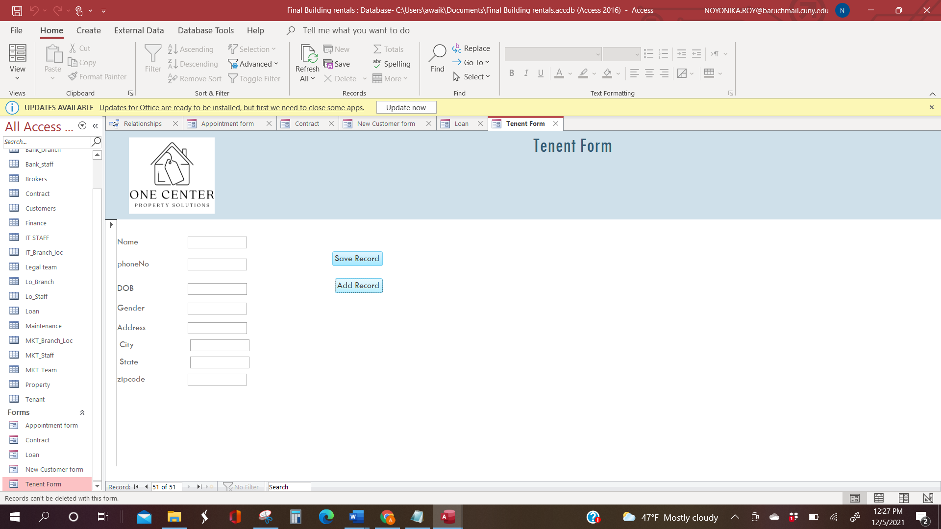

Challenges while making forms:

One of the main challenges we faced while making forms was that the form did not allow new records to be saved and the following error messaged kept showing up:

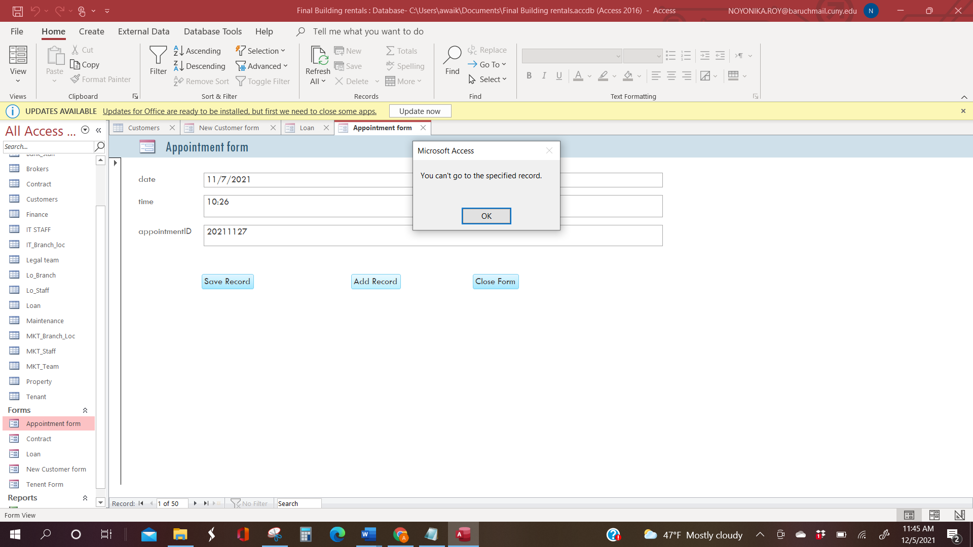

To resolve this, we looked at the properties of the form and learnt that the record source has to be a table not a query to allow record addition. Further the tabs “Allow addition”, “Allow edits” should be set to “yes’ and the locks should not exist.

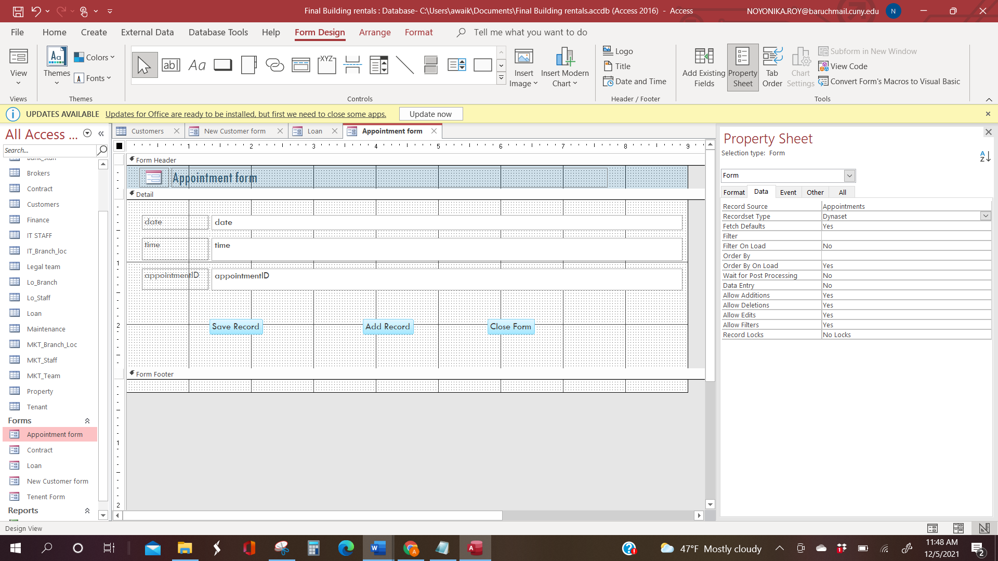

REPORTS:

Reports can be generated on MS Access through the ‘create’ tab. This allows the user to attain summaries of counts, sums, average etc and to make visual graphs from the data attained. One can also group the data for more structured view with this feature.

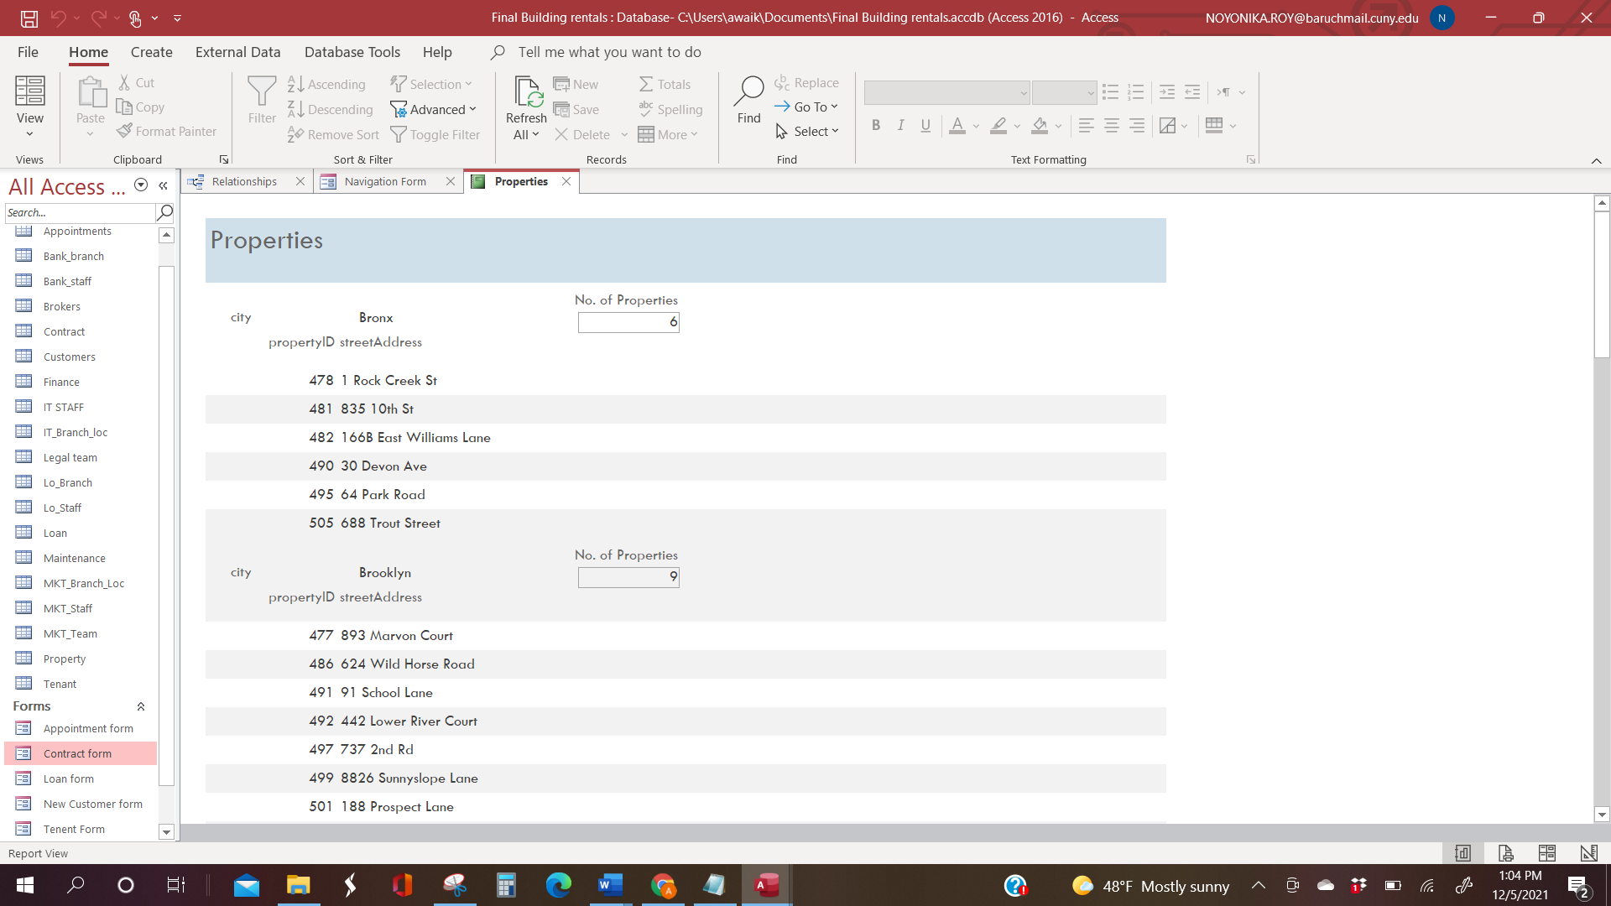

# 

An example of a visual graphic in a report:

# 

# Conclusions

In conclusion, we have managed to develop a database that can be used as an inventory system to provide a framework that enables the end users to manage high bulk of data in the building rental industry.

We have used Microsoft Access 2007 which is the back end. This project was a good teamwork assignment that helped us reinforce the material, practice the SQL coding, and understand a business model. We have gained new knowledge and experience in system analysis, modeling and implementation.

Some parts of the project have been challenging. One of them is data entry because it was time-consuming to add every set of recordsindividually. The optimal solution is to perform a bulk data insertion that was not feasible in the Microsoft Office Access. Creation of the Entity Relationship Diagram (ERD) happened to be another rather challenging activity, as there were multiple revisions. Initially, we created a diagram with many relationship links between the tables that added more complexity to our database design but after brainstorming, we had to find a solution to simplify the tables' relationships by revising the ERD. Once the ERD was finalized and all relationships were revised, converting the ERD to a relational model was smooth. Normalization was a different challenge as we had not factored in normalization at the time we were modelling our ERD hence we had to make changes in successful iterations to be able to reduce redundancy amongst the data and we went step by step checking the conditions of various normal forms and ways to satisfy them. The form design posed a bit of a challenge as we made a form consisting of an aggregation of two entities and we couldn’t update any records to it as we later realized that a join cannot be appended.

Our project is meant to satisfy the needs of rental space owners. It is user-friendly , this package shall prove to be powerful in satisfying all the requirements of the users. Our project is just a simple and humble venture that is easy to understand. However, it can be improved upon to explore higher capabilities and achieve better functionality.